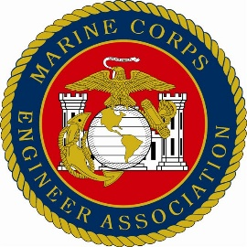
Marine Corps Engineer Association Date________________

CORPORATE APPLICATION FORM

Corporation Name__________________________________________________________

Corporate Address_________________________________________________________

_______________________________________________________

Corporate Point of Contact__________________________________________________

Job Title _________________________________________________________________

Phone # _______________________ E-mail address______________________________

Products or Services___________________________________________________

Corporate Membership Dues $400.00 annually

Annual Awards. The Marine Corps Engineer Association annually sponsors 18 individual and four organization awards for outstanding Marines in Combat Engineer, Engineer Equipment, Utilities, Bulk Fuel and Explosive Ordnance Disposal occupational specialties in addition to an Outstanding Naval Construction Force award for Seabees. Does your corporation desire to become the sponsor of one of the individual awards? Yes_____ No _____ Not At This Time_____

Interested in a Corporate Advertisement in the Reunion Program or Annual Newsletter or on our website? Yes_____ No _____ Not At This Time_____

Make check payable to Marine Corps Engineer Association and mail to the below address or complete the online registration via our website and pay using PayPal or your credit card.
Point of Contact: George Carlson, treasurer@marcorengasn.org, 931-307-9094
MCEA, PO BOX 279 Beechgrove, Tn. 37018-0279
Website: www.MarCorEngAsn.org

