NINETEENTH ANNUAL REUNION

OF THE

MARINE CORPS ENGINEER ASSOCIATION

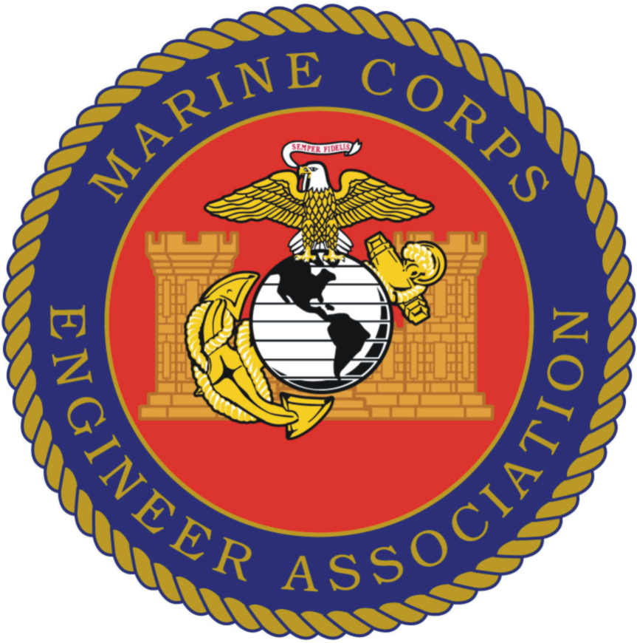

SAN DIEGO, CALIFORNIA

26-28 OCTOBER, 2011

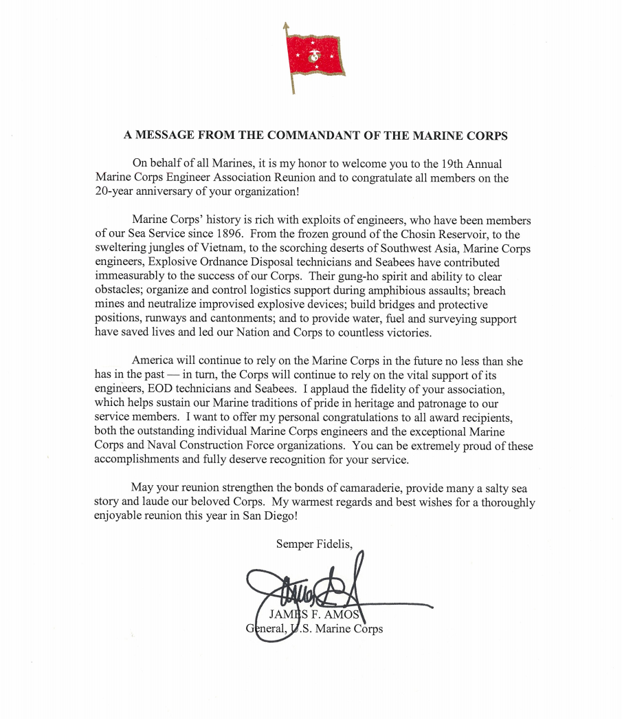

On behalf of our Marine Corps Engineer Association, WELCOME TO ONE & ALL!!

For the 19th time, we come together to visit with our fellow Marines, shipmates, families and friends. In addition, we look forward to meeting new people, exchanging war stories, sharing our pictures, memories and making new acquaintances.

As we’ve done since 1998, we recognize the “Best of the Best” Marine Corps Engineers and EOD. Additionally, we will recognize the complement to our Marine Corps/Navy team-the Outstanding Seabee Battalion. We offer our most profound congratulations to all the individual and unit winners. You have our utmost respect for what you have done and continue to do in support of our beloved Nation. We’re extremely proud of each and every one of you and are blessed because we’re represented by the best!

We also will pause to remember & recognize our members who are no longer with us and who have been added to our Honor Roll; GOD bless them and their loved ones.

Reunions are a significant part of our Corps’ traditions. By maintaining the bonds forged in battle and gathering together to reminisce and to honor those who are no longer with us, we stay true to the ethos we Marines live by.

It is very fitting that we honor and recognize Colonel Jim Marapoti during this year’s gathering. Our Marine Corps Engineer Association celebrates 20 years of existence since Jim and MGySgt. George Hillebrand formed and created our organization.

I’m tremendously pleased to announce our slate of elected Officers for the next two years.
President-Jim Murphy; Los Osos, Calif: served 1951-1971; SSgt; WO; Major
VP-Helmuts Feifs; Durham, NC; 1960-1971; Capt
2d VP- Steve Heesacker- Chapel Hill, NC: 1974-2010; Col
Treasurer-George Carlson; Wartrace, TN; 1968-1990; LtCol
Historian-Phil Martin; Springfield, MA; 1966-2002; MSgt
Chaplain-Doug Kirk; New Albany, OH; 1967-1969 Cpl
Secretary-Ken Frantz: Ashville, NY; 1967-1999; LCpl; Col

Our most sincere thanks to outgoing VP Hank Rudge and 2dVP Jerry Goodwine who have provided superb and sustained support.

Hope to see all of you again next October in Branson, MO.

Please enjoy yourselves and if we can do anything to assist you during the reunion, just let your Executive Committee members know; especially me!!!

GOD Bless and Semper Fidelis;

Ken Frantz Col USMC (Ret) Executive Director/Secretary

PRESIDENT’S MESSAGE

The role of engineers in a military operation is well documented. Hannibal could not have crossed the Alps without engineers to clear the way for his elephants. Alexander the Great’s engineers also paved the way for his advances across Africa and Asia. History is replete with the role engineers have played in helping to form nations of this world. Engineers have occupied significant positions of authority and leadership in this country as well. George Washington was first an engineer. Douglas MacArthur was first an engineer. Our nation’s history contains many great men who, through word, deed or education, could be called “engineer.”
I have concluded that to be called an “Engineer” infers we have a mindset, a process and method of thinking. We aren’t rash; we evaluate, then we act. Engineers are analytical but humane as well. While Eleanor Roosevelt said, “Thank God for the Marines!” She could also have added, “Thank God for the Marine Engineers!” One doesn’t exist without the other.

Our Marine Corps Engineers of today can both look back with pride and forward with full knowledge that they are the smartest, most educated, most skilled and best equipped than any in this nation’s history.

Our motto: “Engineer’s Up!” has a special meaning to those of us who have served. Today, as in the recent past, engineers are task organized into the infantry units as those elements go forward to accomplish their assigned missions. Whatever the requirement, it is a certainty that those Marines will act and do what is necessary: Blow up or build up, that’s what we do and have done and will continue to do so. Other engineer elements, specifically the EOD, intentionally place themselves in extreme harm’s way to ensure the safety of others. Our utility Marines have gone a long way from the old filtration and distillation units to higher technology reverse osmosis systems to ensure, almost behind the scenes, that their fellow Marines have clean, safe drinking water. Our vehicles and equipment could not move were it not for our Bulk Fuel units.

Our Bylaws identify seven factors that have been identified as “Goals/Objectives/Tasks.” From my experience I define these a little differently than someone else might. Goals are longer range and have been developed from the Mission (or “Vision”) of an organization. Objectives are shorter range, something that can be accomplished in perhaps a year or two at the most. Objectives are quantifiable, that is, they can be measured. I often ask the question: “What keeps us from reaching our goal?” By answering this question the specific objective is more carefully defined and the probability of achieving that objective is improved.

I will not restate all seven of these factors but to say we are meeting in San Diego to achieve one of these: Recognizing and honoring outstanding Marines and Marine and related units. Our Executive Committee will be discussing these matters and hopefully arrive at a priority evaluation to decide our emphasis in the coming year.

We have all heard the phrase “Many hands make light work.” That is still a valid statement as we, as volunteers, establish our plans for the future. Reaching out to our current members is equally as important as encouraging new members, active and former, to join our ranks. Our Association has a lot to offer, and I believe that marketing ourselves is the key to success in this area. We all have obligations to family, friends and groups and organizations. Knowing this, you may be asked to volunteer to reach out to a small identified group and invite them aboard. If we all reach out, it makes the effort so much easier and increases the potential of success.

I look forward with great pride and humility to serve you as I am able. The staff of your Association has made it clear they will assist me in whatever ways they can. As I will depend on them, I call upon you to also offer your skills and experiences for the betterment of the Engineer Association.

God bless our Corps and God bless our Engineers!

James (Jim) Murphy

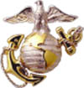
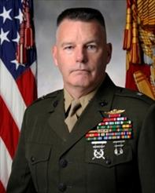

Brigadier General Niel E. Nelson
Commanding General, Training Command

Following commissioning, Brigadier General Nelson attended The Basic School followed by the Engineer School and was assigned to 8th Engineer Support Battalion, where he served as an Engineer platoon commander, company executive officer and company commander. His next tour took him to Inspector-Instructor duty in Bakersfield CA where he served as the I-I. Brigadier General Nelson then attended, and was a Distinguished Graduate of, the U.S. Army Engineer Officer Advance Course.
Returning to the Fleet Marine Force in 1991, he became the S4 and Support Company Commander for 3rd Combat Engineer Battalion and the operations officer of 3rd Special Operations Training Group. In 1994, Brigadier General Nelson reported to the Marine Corps Systems Command where he was the Mine Countermine Project Officer with PM Engineers.
Brigadier General Nelson then attended Marine Corps Command and Staff College followed by the School for Advance Warfighting. In 1999, he reported to II Marine Expeditionary Force G5 as the Southern Command Plans officer and subsequently assumed command of 8th Engineer Support Battalion. This unit served with Task Force Tarawa and 1st Marine Division as an Assault Bridge Battalion during Operation Iraqi Freedom-I.
Following battalion command, Brigadier General Nelson attended the U. S. Army War College and was assigned to U.S. Pacific Command J4 as the Regional Engineer Plans officer for Oceania and Southeast Asia. Following this tour he commanded The Marine Corps Engineer School from 2006 to 2008, after which he became the Chief of Staff, II Marine Expeditionary Force (Forward) and returned to Iraq with the last Multinational Force - West (MNF-W). Upon completion of this tour with MNF-W, he became the Executive Assistant to the Deputy Commandant for Installation and Logistics (DC I&L) and served in this capacity until taking command of Training Command on 12 August 2011.
Brigadier General Nelson graduated from San Diego State University in 1984 receiving a Bachelor of Arts degree. He also holds M.S. Degrees in Systems Management, Military Science and International and Strategic Studies from Capitol College, Marine Corps University and Army War College respectively. Additionally, Brigadier General Nelson is a graduate of The Basic School, Basic and Advanced Engineer Officers Courses, Airborne School, Marine Corps Command and Staff College, USMC School for Advanced Warfighting, Joint Forces Staff College and the Army War College.
Brigadier General Nelson's personal decorations include the Legion of Merit with 2 Gold Stars, Bronze Star with V Device, Defense Meritorious Service medal, Meritorious Service Medal with 1 Gold Star, Joint Service Commendation Medal, Navy and Marine Corps Commendation Medal with 2 Gold Stars, Army Commendation Medal, Navy Achievement Medal and the Combat Action Ribbon.
Brigadier General Nelson is married and has two children, both Marine Corps Officers.

2011 AWARD RECIPIENTS

COMBAT ENGINEER OFFICER CAPT. J.R. MONTEDORO 8TH ESB

COMBAT ENGINEER SNCO GYSGT. J.G. MORRIS CLB 3

COMBAT ENGINEER NCO CPL. D.R. BENEDICT 1ST CEB

COMBAT ENGINEER MARINE LCPL J.M. PEREZ 2D CEB

ENGINEER EQUIPMENT OFFICER CWO3 A.J. REITER 3D MAINT BN

ENGINEER EQUIPMENT SNCO SSGT. D.J. FLETCHER 9TH ESB

ENGINEER EQUIPMENT NCO CPL. O.J. GONZALEZ-RAMIREZ 1ST CEB

ENGINEER EQUIPMENT MARINE CPL. D. E. CONKINS 8TH ESB

UTILITIES OFFICER CWO4 M.S. MORRIS 8TH ESB

UTILITIES SNCO SSGT. J.L. HOFFMAN 1ST CEB

UTILITIES NCO SGT. R.E. BATTLES 1ST CEB

UTILITIES MARINE LCPL K.L. GORMAN 1ST CEB

BULK FUEL OFFICER CWO4 B.T. CADIZ MWSS 172

BULK FUEL SNCO GYSGT. G.C. PRUITT 8TH ESB

BULK FUEL NCO CPL. K.A. RIQUINHA 9TH ESB

BULK FUEL MARINE LCPL. O.Y. FALU 9TH ESB

EOD OFFICER CWO2 J.W. HERMANN 1STSPOPSBN

SSgt William Callahan Memorial EOD Tech Award
GYSGT D.G. BENDER 7TH ESB

COMBAT ENGINEER BATTALION 1ST CEB 1ST MARDIV

3RD CEB 1ST MARDIV

ENGINEER SUPPORT BATTALION 8TH ESB 2D MLG

MWSS, ENGINEER COMPANY MWSS 373 3RD MAW

NAVAL CONSTRUCTION FORCE UNIT NMCB 5 1ST NCD

The MARINE CORPS ENGINEER ASSOCIATION TAKES PLEASURE IN PRESENTING THE

COMBAT ENGINEER OFFICER OF THE YEAR AWARD TO

CAPTAIN JOSEPH R. MONTEDORO
UNITED STATES MARINE CORPS

FOR SERVICE SET FORTH IN THE FOLLOWING:

FOR SUPERIOR PERFORMANCE OF DUTY WHILE SERVING AS COMPANY COMMANDER, ENGINEER SUPPORT COMPANY, 8TH ENGINEER SUPPORT BATTALION, 2D MARINE LOGISTICS GROUP, II MARINE EXPEDITIONARY FORCE FROM 1 APRIL 2010 TO 31 MARCH 2011. CAPTAIN MONTEDORO DEVELOPED, IMPLEMENTED, AND SUPERVISED THE EXECUTION OF A COMPREHENSIVE AND INTENSIVE PRE-DEPLOYMENT TRAINING PLAN ENSURING HIS MARINES WERE FULLY TRAINED FOR THEIR COMBAT MISSION. DURING HIS COMBAT DEPLOYMENT TO AFGHANISTAN, HIS LEADERSHIP AND INITIATIVE ENSURED HIS COMPANY WAS ABLE TO PROVIDE TACTICALLY AGILE AND OPERATIONALLY RESPONSIVE ENGINEER SUPPORT. HIS EXCEPTIONAL TACTICAL PROFICIENCY AND DEDICATION TO MISSION ACCOMPLISHMENT WERE INSTRUMENTAL IN THE SUCCESSFUL COMPLETION OF OVER 60 KILOMETERS OF LIMITED ALL WEATHER ROADS THROUGHOUT HIGHLY KINETIC REGIONS WITHIN HELMAND PROVINCE. HIS EFFORTS ENABLED THE TACTICAL MOBILITY OF REGIONAL COMMAND-SOUTHWEST FORCES AND PROVIDED THEM THE FREEDOM OF MANEUVER REQUIRED TO OPEN PATROL BASES AND SUCCESSFULLY INTERDICT INSURGENTS THROUGOUT MARJEH AND THE UPPER SANGIN RIVER VALLEY. DEMONSTRATING OUSTANDING LEADERSHIP, HE TIRELESSLY PURSUED A ROBUST EQUIPMENT MAINTENANCE EFFORT. HIS DETERMINED FOCUS RESULTED IN THE MARKED INCREASE OF HIS COMPANY’S MAINTENANCE READINESS FROM 68 PERCENT AT THE BEGINNING OF THE DEPLOYMENT TO 97 PERCENT; SIGNIFICANTLY CONTRIBUTING TO THE BATTALION’S ABILITY TO CONDUCT COMBAT OPERATIONS. CAPTAIN MONTEDORO’S INITIATIVE, PERSEVERANCE, AND TOTAL DEDICATION TO DUTY REFLECTED GREAT CREDIT UPON HIMSELF AND WERE IN KEEPING WITH THE HIGHEST TRADITIONS OF THE MARINE CORPS AND THE UNITED STATES NAVAL SERVICE.

The MARINE CORPS ENGINEER ASSOCIATION TAKES PLEASURE IN PRESENTING THE

COMBAT ENGINEER STAFF NONCOMMISSIONED OFFICER OF THE YEAR AWARD TO

GUNNERY SERGEANT JERRY G. MORRIS
UNITED STATES MARINE CORPS

FOR SERVICE SET FORTH IN THE FOLLOWING:

FOR SUPERIOR PERFORMANCE OF DUTIES WHILE SERVING PLATOON SERGEANT, 2D PLATOON, MOBILITY ASSAULT COMPANY, 1ST COMBAT ENGINEER BATTALION, 1ST MARINE DIVISION FROM 1 APRIL 2010 TO 31 MARCH 2011. ON 9 NOVEMBER 2010WHILE IN CONNECTION WITH COMBAT OPERATIONS INVOLVING CONFLICT WITH AN OPPOSING FORCE IN SUPPORT OF OPERATION ENDURING FREEDOM. 2D PLATOON’S LEAD VEHICLE STRUCK AN IED WHICH TRIGGERED AN AGGRESSIVE AMBUSH FROM AN ENEMY SQUAD SIZED REINFORCED ELEMENT, GUNNERY SERGEANT MORRIS COURAGEOUSLY EXPOSED HIMSELF TO AK-47 AND MACHINE GUN FIRE; ESTABLISHING SECURITY AND COORDINATED THE EXTRACTION AND EVACUATION OF THE CASUALTY WHILE SIMULTANEOUSLY CALLING OUT DISTANCES AND MARKING TARGETS WITH YELLOW SMOKE ENABLING THE PLATOON MACHINE GUNNERS TO PROVIDE COVER FIRE WITH DEVASTATING RESULTS. ON 16 DECEMBER 2010, THE PLATOON’S LEAD COUGAR TOOK A DIRECT HIT FROM AN IED WHICH IMMEDIATELY TRIGGERED ENEMY MORTAR AND SMALL ARMS FIRES. GUNNERY SERGEANT MORRIS, BOLDLY AND VALIANTLY, WHILE EXPOSED TO ENEMY FIRE FROM THE SOUTH, SUCCESSFULLY CLEARED THE SURROUNDING AREA OF ALL IED THREATS AND SPEARHEADED THE EXTRACTION OF THE FOUR MARINES OUT OF THE DOWN VEHICLE WHILE SIMULTANEOUSLY ENSURING THE EFFECTIVE FIRES OF ALL WEAPON SYSTEMS WERE HELD IN FORCE; ULTIMATELY FORCING THE DETERMINED ENEMY TO RETREAT. ON 16 JANUARY 2011, THE PLATOON WAS DECISIVELY ENGAGED BY AK-47 AND RPG FIRES. GUNNERY SERGEANT MORRIS AGAIN EXPOSED HIMSELF TO ENEMY FIRES AND BRILLIANTLY EXECUTED MARKING MULTIPLE TARGETS WITH YELLOW SMOKE, ALLOWING THE PLATOON TO MASS ALL FIRES ON THE ENEMY. GUNNERY SERGEANT MORRIS’ INITIATIVE, PERSEVERANCE, AND TOTAL DEDICATION TO DUTY REFLECTED CREDIT UPON HIM AND UPHELD THE HIGHEST TRADITIONS OF THE MARINE CORPS AND THE UNITED STATES NAVAL SERVICE.

The MARINE CORPS ENGINEER ASSOCIATION TAKES PLEASURE IN PRESENTING THE

COMBAT ENGINEER NONCOMMISSIONED OFFICER OF THE YEAR AWARD TO

CORPORAL DANIEL R. BENEDICT
UNITED STATES MARINE CORPS

FOR SERVICE SET FORTH IN THE FOLLOWING:

FOR HEROIC ACHIEVEMENT IN THE SUPERIOR PERFORMANCE OF HIS DUTIES WHILE SERVING AS A COMBAT ENGINEER FIRE TEAM LEADER, 3RD PLATOON, COMPANY C, 1ST COMBAT ENGINEER BATTALION FROM 1 APRIL 2010 TO 31 MARCH 2011. DURING THIS PERIOD, CORPORAL BENEDICT PROVIDED UNSURPASSED MOBILITY, COUNTER- MOBILITY, AND SURVIVABILITY SUPPORT TO COMPANY I, 3RD BATTALION, 5TH MARINES. PARTICIPATING IN MORE THAN 60 COMBAT PATROLS, HE DISCOVERED 11 IMPROVISED EXPLOSIVE DEVICES AND 2 ENEMY WEAPONS CACHES. TAKING THE POINT POSITION ON MANY OF THESE PATROLS, HE CONSISTENTLY EXPOSED HIMSELF TO THE ENEMY THREAT WHILE “SWEEPING” AND MARKING SAFE LANES FOR THE INFANTRY TO MANEUVER ACROSS THE BATTLE SPACE, OFTEN WHILE UNDER FIRE. IN ADDITION, CORPORAL BENEDICT PLANNED AND COORDINATED A PLATOON OPERATION INVOLVING THE DEMOLITION OF NUMEROUS COMPOUNDS AND THE INTEGRATION OF THE AFGHANISTAN NATIONAL ARMY, IMPROVING THE RELATIONSHIP BETWEEN THEM AND THE LOCAL POPULATION OF SANGIN, AFGHANISTAN. CORPORAL BENEDICT EMPLOYED HIS ADVANCED KNOWLEDGE OF DEMOLITIONS TO REDUCE NUMEROUS COMPOUNDS AND WALLS TO INCREASE THE OBSERVATION AND FIELDS OF FIRE FROM PATROL BASE SANGIN FULHAD. ADDITIONALLY, HE TRAINED OVER 40 MARINES AND 20 AFGHANISTAN NATIONAL ARMY SOLDIERS IN THE EMPLOYMENT OF THE VALLON METAL DETECTOR, VISUAL INDICATORS OF IMPROVISED EXPLOSIVE DEVICES, AND KNOWN ENEMY TACTICS, TECHNIQUES, AND PROCEDURES FOR THEIR EMPLACEMENT BASED ON HIS EXPERIENCE WITH THE ENEMY THREAT. CORPORAL BENEDICT’S INITIATIVE, PERSEVERANCE, AND TOTAL DEDICATION TO DUTY REFLECT CREDIT UPON HIMSELF AND WERE IN KEEPING WITH THE HIGHEST TRADITIONS OF THE MARINE CORPS AND THE UNITED STATES NAVAL SERVICE.

The MARINE CORPS ENGINEER ASSOCIATION TAKES PLEASURE IN PRESENTING THE

COMBAT ENGINEER MARINE OF THE YEAR AWARD TO

LANCE CORPORAL JAMES M. PEREZ
UNITED STATES MARINE CORPS

FOR SERVICE SET FORTH IN THE FOLLOWING:

FOR HEROIC ACHIEVEMENT IN THE SUPERIOR PERFORMANCE OF HIS DUTIES WHILE SERVING AS A FIRE TEAM LEADER FOR 3RD PLATOON, COMBAT ENGINEER COMPANY, COMBAT ASSAULT BATTALION, 3D MARINE DIVISION FROM 1 AUGUST 2010 TO 31 MARCH 2011 DURING COMBAT OPERATIONS IN AFGHANISTAN IN SUPPORT OF OPERATION ENDURING FREEDOM. DURING THIS PERIOD, LANCE CORPORAL PEREZ DEMONSTRATED A HIGH DEGREE OF INIATIVE AND LEADERSHIP WHILE PARTICIPATING IN 100-PLUS COMBAT PATROLS IN THE VOLATILE MARJAH AND SANGIN DISTRICTS. IN THE SANGIN DISTRICT HE SINGLEHANDEDLY EMPLOYED OVER 100 POUNDS OF MILITARY EXPLOSIVES IN SUPPORT OF AT LEAST 40 HIGHLY KINETIC ASSAULT BREACHING OPERATIONS. HIS ENGINEER EXPERTISE WAS FURTHER EXEMPLIFIED IN HIS ASTUTE ABILITY TO EMPLOY HIS DETECTION EQUIPMENT TO DETECT MINES AND IMPROVISED EXPLOSIVE DEVICES. WHILE BUILDING AN OBSERVATION POST, LANCE CORPORAL PEREZ’S SQUAD CAME UNDER INTENSE ENEMY MACHINE GUN FIRE RESULTING IN A SEVERE GUNSHOT WOUND TO ONE HIS FELLOW MARINES. NOTICING THIS, LANCE CORPORAL PEREZ EXPOSED HIMSELF TO ENEMY FIRE, DRAGGED THE WOUNDED MARINE TO A COVERED POSITION, AND APPLIED A TOURNIQUET TO THE MARINE’S LEG. HIS UNHESITATING HEROIC ACTIONS SAVED HIS FELLOW MARINE’S LIFE. LANCE CORPORAL PEREZ’S, LEADERSHIP AND DEDICATION TO DUTY REFLECTED GREAT CREDIT UPON HIM AND WERE IN KEEPING WITH THE HIGHEST TRADITIONS OF THE UNITED STATES MARINE CORPS AND THE NAVAL SERVICE.

The MARINE CORPS ENGINEER ASSOCIATION TAKES PLEASURE IN PRESENTING THE

ENGINEER EQUIPMENT OFFICER OF THE YEAR AWARD TO

CHIEF WARRANT OFFICER 3 ANTHONY REITER
UNITED STATES MARINE CORPS

FOR SERVICE SET FORTH IN THE FOLLOWING:

FOR MERITORIOUS SERVICE WHILE SERVING AS PLATOON COMMANDER, OPERATIONS PLATOON, ENGINEER COMPANY, COMBAT LOGISTICS BATTALION 3, FROM 1 APRIL 2010 TO 31 MARCH 2011. CHIEF WARRANT OFFICER REITER WAS RESPONSIBLE FOR INTEGRATING 73 MARINES AND 12 DIFFERENT MILITARY OCCUPATIONAL SPECIALITES, COMING FROM 10 DIFFERENT PARENT COMMANDS, IN PREPARATION FOR A DEPLOYMENT IN SUPPORT OF OPERATION ENDURING FREEDOM. HIS EXPERIENCE, MOTIVATION, AND LEADERSHIP TURNED THESE AUGMENTS INTO A COHESIVE UNIT AND WERE INSTRUMENTAL IN THE FORMATION OF NOT ONLY HIS PLATOON, BUT HIS COMPANY AND BATTALION, AS THEY CONDUCETD THEIR THREE MONTH WORKUP IN OKINAWA, HAWAII, AND CALIFORNIA. WHILE DEPLOYED IN SUPPORT OF OPERATION ENDURING FREEDOM 10.2, CHIEF WARRANT OFFICER REITER SERVED AS A MISSION COMMANDER ON NUMEROUS HORIZONTAL CONSTRUCTION MISSIONS, PROVIDING DIRECT SUPPORT GENERAL ENGINEERING TO REGIMENTAL COMBAT TEAM 1. HE LED A PLATOON OF HEAVY EQUIPMENT OPERATORS AND COMBAT ENGINEERS DURING 12 WEEKS OF ROAD REPAIR IN THE GARMSIR DISTRICT OF HELMAND PROVINCE, AFGHANISTAN. UNDER HIS DIRECTION, HIS UNIT OPENED A MAJOR GROUND LINE OF COMMUNICATION FOR 2D BATTALION, 1ST MARINES, IMPROVING SAFETY AND MOBILITY ALONG A 16 KILOMETER STRETCH OF ROAD. HE DISPLAYED UNWAIVERING PROFESSIONALISM WHILE INTERACTING WITH AFGHAN CIVILIANS ON A DAILY BASIS, ENGAGING LOCAL ELDERS AND ASSITING FARMERS WITH THEIR IRRIGATION EFFORTS IN CONJUNCTION WITH HIS TACTICAL TASKS. IN ADDITION TO HIS ROLE AS A PLATOON COMMANDER, CHIEF WARRANT OFFICER REITER SERVED COLLATERALLY AS THE COMPANY’S MAINTENANCE OFFICER, MANAGING AND COORDINATING MAINTENANCE EFFORTS FOR HIS COMPANY’S 72 TACTICAL VEHICLES AND TRAILERS, AND 45 ENGINEER EQUIPMENT END ITEMS. THROUGHOUT THE WORKUP AND DEPLOYMENT, HIS ABILITY TO LEAD AND EMPLOY NOT ONLY HEAVY EQUIPMENT OPERATORS, BUT UTILITIES MARINES, BULK FUEL MARINES, MOTOR TRANSPORT MARINES, AND MECHANICS IN A COORDINATED EFFORT SIGNIFICANTLY IMPACTED HIS UNIT’S ABILITY TO ACCOMPLISH ANY ASSIGNED MISSION. CHIEF WARRANT OFFICER REITER’S LEADERSHIP, TECHNICAL PROFICIENCY, AND PROFESSIONALISM REFLECTED GREAT CREDIT UPON HIMSELF AND WERE IN KEEPING WITH THE HIGHEST TRADITIONS OF THE MARINE CORPS AND THE UNITED STATES NAVAL SERVICE.

The MARINE CORPS ENGINEER ASSOCIATION TAKES PLEASURE IN PRESENTING the

ENGINEER EQUIPMENT STAFF NONCOMMISSIONED OFFICER
OF THE YEAR AWARD TO

STAFF SERGEANT D. J. FLETCHER
UNITED STATES MARINE CORPS

FOR SERVICE SET FORTH IN THE FOLLOWING:

FOR SUPERIOR PERFORMANCE OF DUTY WHILE SERVING AS HEAVY EQUIPMENT PLATOON, PLATOON SERGEANT, AND OPERATIONS CHIEF, ENGINEER SUPPORT COMPANY, 9TH ENGINEER SUPPORT BATTALION, 3D MARINE LOGISTICS GROUP, III MARINE EXPEDITIONARY FORCE FROM 1 APRIL 2010 TO 31 MARCH 2011. THROUGHOUT THIS PERIOD, STAFF SERGEANT FLETCHER PERFORMED HIS DUTIES IN AN EXEMPLARY AND HIGHLY PROFESSIONAL MANNER. HIS LEADERSHIP, KNOWLEDGE AND GUIDANCE WERE KEY IN SWIFTLY ORGANIZING AND TRAINING A PLATOON OF MARINES FROM NUMEROUS COMMANDS, PREPARING THEM FOR A DEPLOYMENT IN SUPPORT OF OPERATION ENDURING FREEDOM, IN HELMAND PROVINCE AFGHANISTAN. HIS TIRELESS EFFORTS AND TECHNICAL EXPERTISE DIRECTLY CONTRIBUTED TO THE COMPLETION OF SECURITY FACILITIES AND THE IMPROVEMENT OF MAIN SUPPLY ROUTES. THESE EFFORTS CONTRIBUTED SIGNIFICANTLY TO THE COUNTERINSURGENCY EFFORTS BY DEVELOPING SECURITY CAPACITY AND IMPROVING UNRESTRICTED MOVEMENT THROUGHOUT THE CITY OF MARJAH. WITHIN SEVEN DAYS, HIS EXCELLENT ORGANIZATION AND DIRECT SUPERVISION ENABLED HIS DETACHMENT TO COMPLETE CONSTRUCTION OF AN AFGHAN UNIFORMED POLICE SUB-STATION IN JUST SEVEN DAYS. THIS ENABLED RAPID FIELDING AND BASING OF A 300-MAN AFGHAN SECURITY FORCE WHICH DIRECTLY CONTRIBUTED TO A LOCAL POLICE LED SECURITY INITIATIVE. HE LED A DETACHMENT WHICH COMPLETED SIGNIFICANT ROAD IMPROVEMENTS OF A MAJOR SUPPLY ROUTE; HIS ACTIONS REDUCED IED ACTIVITY, WIDENED ROUTES, AND INCREASED FREEDOM OF MOVEMENT FOR ALL UNITS MANEUVERING THROUGHOUT MARJAH. HIS TIMELY AND FOCUSED ENGINEERING EFFORTS WERE INVALUABLE TO REGIONAL COMMAND SOUTHWEST UNITS AND SIGNIFICANTLY CONTRIBUTED TO COIN OPERATIONS. STAFF SERGEANT FLETCHER’S ENTHUSIASM, PROFESSIONALISM, AND UNWAVERING DEVOTION TO DUTY REFLECTED GREAT CREDIT UPON HIM AND ARE IN KEEPING WITH THE HIGHEST TRADITIONS OF THE MARINE CORPS AND THE UNITED STATES NAVAL SERVICE.

The MARINE CORPS ENGINEER ASSOCIATION TAKES PLEASURE IN PRESENTING THE

ENGINEER EQUIPMENT NONCOMMISSIONED OFFICER OF THE YEAR AWARD TO

CORPORAL OSCAR J. GONZALEZ-RAMIREZ

UNITED STATES MARINE CORPS

FOR SERVICE SET FORTH IN THE FOLLOWING:

FOR MERITORIOUS SERVICE WHILE SERVING AS HEAVY EQUIPMENT MECHANIC AND ENGINEER SUPPORT SQUAD LEADER, 1ST PLATOON, COMPANY C, 1ST COMBAT ENGINEER BATTALION FROM MAY 2010 TO APRIL 2011. DURING THIS PERIOD, CORPORAL GONZALES-RAMIREZ PERFORMED HIS DUTIES IN AN EXEMPLARY AND HIGHLY PROFESSIONAL MANNER. HE SUPERVISED THE ENGINEER SUPPORT SQUAD AND SERVED AS HEAVY EQUIPMENT MECHANIC IN SUPPORT OF OPERATION ENDURING FREEDOM IN THE GARMSIR DISTRICT, HELMAND PROVINCE, AFGHANISTAN. AS THE LONE HEAVY EQUIPMENT MECHANIC IN THE BATTLE SPACE, CORPORAL GONZALES-RAMIREZ MAINTAINED ALL HEAVY EQUIPMENT ASSETS FOR HIS SUPPORTED BATTALION, AS WELL AS MANAGING A SUPPORT SQUAD COMPRISED OF 8 MARINES OF DIFFERENT OCCUPATIONAL SPECIALTY. CORPORAL GONZALES-RAMIREZ PROVIDED OUTSTANDING SUPPORT TO 2D BATTALION, 1ST MARINES, DISPLAYING EXPERTISE AND LEADERSHIP FAR ABOVE WHAT IS EXPECTED OF HIS RANK AND EXPERIENCE. PERFORMING THE DUTIES OF BOTH HEAVY EQUIPMENT MECHANIC AND OPERATOR, CORPORAL GONZALESRAMIREZ WAS AN INVALUABLE ASSET TO HIS SUPPORTED BATTALION. IN ADDITION TO HIS DUTIES AS A MECHANIC, CORPORAL GONZALES-RAMIREZ ALSO PERFORMED SEVERAL MISSIONS AS AN INCIDENTAL HEAVY EQUIPMENT OPERATOR, CLEARING AREAS CONSTANTLY USED BY ENEMY FORCES TO PREVENT EMPLACEMENT OF IMPROVISED EXPLOSIVE DEVICES, CONDUCTING DEMILITARIZATION PROJECTS, PATROL BASE BUILDS AND IMPROVEMENTS. CORPORAL GONZALES-RAMIREZ’ LEADERSHIP WAS CRITICAL IN MAINTAINING THE OPERATION OF THE BATTALION’S HEAVY EQUIPMENT ASSETS IN EXTREME AND AUSTERE CONDITIONS. HIS EXPERIENCE, PROFESSIONALISM, AND UNMATCHED WORK ETHIC AND DEDICATION TO DUTY REFLECT GREAT CREDIT UPON HIM AND WERE IN KEEPING WITH THE HIGHEST TRADITIONS OF THE MARINE CORPS AND THE UNITED STATES NAVAL SERVICE.

THE MARINE CORPS ENGINEER ASSOCIATION TAKES PLEASURE IN PRESENTING THE

ENGINEER EQUIPMENT MARINE OF THE YEAR AWARD TO

LANCE CORPORAL DANE E. CONKINS
UNITED STATES MARINE CORPS

FOR SERVICE SET FORTH IN THE FOLLOWING:

FOR OUTSTANDING ACHIEVEMENT IN THE SUPERIOR PERFORMANCE OF HIS DUTIES DURING OPERATION ENDURING FREEDOM 10-1, AS A HEAVY EQUIPMENT OPERATOR, ENGINEER OPERATIONS COMPANY, MARINE WING SUPPORT SQUADRON 171, MARINE WING SUPPORT GROUP 17, 1ST MARINE AIRCRAFT WING, III MARINE EXPEDITIONARY FORCE, U.S. MARINE FORCES PACIFIC FROM 1 APRIL 2010 TO 31 MARCH 2011. THROUGHOUT THIS PERIOD, LANCE CORPORAL CONKINS’ SELFLESS ACTS OF HEROISM AND LEADERSHIP DIRECTLY AFFECTED OVERALL MISSION SUCCESS. HE SAVED LIVES AND CRITICAL EQUIPMENT AND APPLIED HIS TECHNICAL SKILLS TO EVERY MISSION ESSENTIAL AND TIME CRITICAL ENGINEERING SITUATION. JUST FIVE DAYS AFTER ARRIVAL TO CAMP LEATHERNECK, A FIRE ERUPTED WITHIN THE COMPOUND AND WAS QUICKLY SPREADING. LANCE CORPORAL CONKINS DISREGARDED HIS OWN PERSONAL SAFETY AND QUICKLY ASSESSED THE RAPIDLY DETERIORATING SITUATION. SKILLFULLY USING THE CAPABILITIES OF THE BULLDOZER HE WAS OPERATING, LANCE CORPORAL CONKINS CREATED A BERM TO PREVENT THE SPREAD OF FIRE TO THE REMAINING CAMP. HE THEN USED HIS DOZER TO PUSH A STRANDED TRUCK CLEAR OF THE EVER INCREASING FIRE. AFTER AN EXPLOSION RENDERED A FELLOW MARINE UNCONSCIOUS AND TRAPPED INSIDE A DISABLED VEHICLE WHICH WAS SURROUNDED BY FIRE, LANCE CORPORAL CONKINS SELFLESSLY RACED TO AID THE INJURED MARINE AND PULLED HIM TO SAFETY. BACK TO HIS DOZER, LANCE CORPORAL CONKINS RESUMED HIS EFFORTS TO COMBAT THE FIRE. LANCE CORPORAL CONKINS REPEATED AND DELIBERATE SELFLESS ACTS HELPED SAVE NEARLY 10 MILLION DOLLARS OF EQUIPMENT AND THE LIFE OF A FELLOW MARINE. THROUGHOUT 11 MAJOR ENGINEERING MISSIONS, LANCE CORPORAL CONKINS ASSISTED IN THE CONSTRUCTION OF POLICE STATIONS, BRIDGES, ROADS, AND ASSISTED IN IMPROVISED EXPLOSIVE DEVISE CLEARING OPERATIONS IN SUPPORT OF EXPLOSIVE ORDNANCE DISPOSAL TEAM EFFORTS WHILE REPEATEDLY BEING SUBJECTED TO SMALL ARMS FIRE. LANCE CORPORAL CONKINS’ SELFLESS DEVOTION TO DUTY, EXCEPTIONAL BRAVERY REFLECTED GREAT CREDIT UPON HIM AND WERE IN KEEPING WITH THE HIGHEST TRADITIONS OF THE MARINE CORPS AND THE UNITED STATES NAVAL SERVICE.

THE MARINE CORPS ENGINEER ASSOCIATION TAKES PLEASURE IN PRESENTING THE

UTILITIES OFFICER OF THE YEAR AWARD TO

CHIEF WARRANT OFFICER 4 MICHAEL S. MORRIS
UNITED STATES MARINE CORPS

FOR SERVICE SET FORTH IN THE FOLLOWING:

FOR SUPERIOR PERFORMANCE OF DUTY WHILE SERVING AS UTILITIES PLATOON COMMANDER, ENGINEER SUPPORT COMPANY, 8TH ENGINEER SUPPORT BATTALION, 2D MARINE LOGISTICS GROUP, II MARINE EXPEDITIONARY FORCE FROM 1 APRIL 2010 TO 31 MARCH 2011. CHIEF WARRANT OFFICER MORRIS’S PRECISE UNDERSTANDING OF THE FORCE LAY DOWN ACROSS HELMAND PROVINCE ENABLED HIM TO FORESEE THE NEED TO HAVE TECHNICALLY COMPETENT MARINES AT EACH WATER SITE. SUBSEQUENTLY, HE ORDERED 32 MARINES TO ADVANCED OCCUPATIONAL SCHOOLING PRIOR TO DEPLOYMENT. Upon ARRIVING IN Afghanistan, Chief Warrant Officer Morris quickly organized his platoon into Tiger Teams, task organized teams of Utilities Marines composed of various OCCUPATIONAL SPECIALTIES, used to surge support AT A specific SITE, for a finite period of time, and train supported units on safety, preventive and corrective equipment maintenance, and efficient mobile electric power system employment. CHIEF WARRANT OFFICER MORRIS ALSO SUPERVISED 10 WATER SITES ACROSS REGIONAL COMMAND (SOUTHWEST). tHESE SITES HAVE PRODUCED AND DISTRIBUTED OVER 4.2 MILLION GALLONS OF POTABLE WATER, PROVIDED OVER 160,500 SHOWERS, AND LAUNDERED OVER 128,000 POUNDS OF LAUNDRY FOR COALITION FORCES WITHIN HELMAND PROVINCE. FOR AN INNOVATIVE, NON-STANDARD SOLUTION TO WATER DISTRIBUTION, HE DESIGNED A WATER PUMP SYSTEM deliverING a two inch water column up a 954 foot cliff, WITH A 60 DEGREE SLOPE. reaching from the Kajaki Dam Water Basin to the ridgeline, The system pumps water ACROSS the ridgeline’s peaks an additional 5,500 feet to a combat outpost, ESTABLISHING A water distribution point. CHIEF WARRANT OFFICER MORRIS’S INITIATIVE, PERSEVERANCE AND TOTAL DEDICATION TO DUTY REFLECTED GREAT CREDIT UPON HIMSELF AND WERE IN KEEPING WITH THE HIGHEST TRADITIONS OF THE MARINE CORPS AND UNITED STATES NAVAL SERVICE.

THE MARINE CORPS ENGINEER ASSOCIATION TAKES PLEASURE IN PRESENTING THE

UTILITIES STAFF NONCOMMISSIONED OFFICER OF THE YEAR AWARD TO

STAFF SERGEANT JOSHUA L. HOFFMAN
UNITED STATES MARINE CORPS

FOR SERVICE SET FORTH IN THE FOLLOWING:

FOR SUPERIOR PERFORMANCE OF DUTIES WHILE SERVING AS UTILITIES CHIEF, UTILITIES PLATOON, 1ST COMBAT ENGINEER BATTALION, FROM 1 APRIL 2010 TO 31 MARCH 2011. WHILE PREPARING TO DEPLOY IN SUPPORT OF COMBAT OPERATIONS TO AFGHANISTAN, HE DEVELOPED AND EXECUTED A DELIBERATE TRAINING PTP SCHEDULE THAT WOULD PREPARE HIS YOUNG PLATOON FOR COMBAT. THROUGHOUT THE DEPLOYMENT, STAFF SERGEANT HOFFMAN DREW UPON HIS EXTENSIVE COMBAT EXPERIENCE TO SOLVE COMPLICATED UTILITIES ISSUES FOR FIRST AND SECOND MARINE DIVISION. AS THE UTILITIES CHIEF FOR FOB DWYER, HE WAS ABLE TO RAISE THE READINESS FROM 50 PERCENT TO 90 PERCENT IN TWO MONTHS. HE DEVELOPED A CIRCUITOUS MAINTENANCE PROGRAM THAT ENABLED HIS MARINES TO TRAVEL THROUGHOUT THE RCT 1 AND RCT 8 AREA OF OPERATIONS TO CONDUCT UTILITIES ASSESSMENTS TO 4 FOBS, 17 COPS, AND 21 PB’S. HE COORDINATED THE MOVEMENT OF UTILITIES EQUIPMENT TO ONE CONSOLIDATED LOCATION TO ENSURE THAT ALL BROKEN EQUIPMENT WAS PROPERLY INSPECTED AND INDUCTED IN THE MAINTENANCE CYCLE. ADDITIONALLY, HE INSTALLED $28,000 WORTH OF INTERIOR WIRING TO FOB CAFARATTA. LATER IN THE DEPLOYMENT HE TOOK ON THE DUTIES AS REGIMENTAL COMBAT TEAM 8 UTILITIES CHIEF, MANAGING THE MAINTENANCE OF 143 PRINCIPLE END ITEMS. HE DIRECTLY SUPPORTED 3 INFANTRY BATTALIONS AND 1 ARTILLERY BATTALION IN THE NORTHERN AO. DURING THE DEPLOYMENT STAFF SERGEANT HOFFMAN HAS TRAVELED MORE THAN 1250 MILES VIA CONVOY AND MANIFESTED ASSAULT SUPPORT REQUESTS TO PROVIDE UTILITIES SUPPORT TO THE MANY UNITS OF THE DIVISION. STAFF SERGEANT HOFFMAN’S INITIATIVE, PERSEVERANCE, AND TOTAL DEDICATION TO DUTY REFLECTED CREDIT UPON HIM AND UPHELD THE HIGHEST TRADITIONS OF THE MARINE CORPS AND THE UNITED STATES NAVAL SERVICE.

THE MARINE CORPS ENGINEER ASSOCIATION TAKES PLEASURE IN PRESENTING THE

UTILITIES NONCOMMISSIONED OFFICER OF THE YEAR AWARD TO

SERGEANT ROBERT E. BATTLES
UNITED STATES MARINE CORPS

FOR SERVICE SET FORTH IN THE FOLLOWING:

FOR SUPERIOR PERFORMANCE OF HIS DUTIES WHILE SERVING AS UTILITIES CHIEF, UTILITIES PLATOON, ENGINEER SUPPORT COMPANY, 1ST COMBAT ENGINEER BATTALION FROM 14 JULY 2010 – 15 APRIL 2011. HIS EFFORTS SPANNED THE SPECTRUM OF TACTICAL ELECTRICAL SUPPLY SUPPORT AND WERE ESSENTIAL IN THE EXECUTION OF NUMEROUS TRAINING EXERCISES AS WELL AS POWERING FORWARD OPERATING BASES THAT HOUSED MORE THAN 400 COMBAT TROOPS AS WELL AS ASSETS WHICH FACILITATED COMMAND AND CONTROL OPERATIONS. IN A DEMANDING COMBAT ENVIRONMENT HE PROVIDED EXCEPTIONAL UTILITIES SUPPORT TO FIRST COMBAT ENGINEER BATTALION AND THREE INFANTRY BATTALIONS BY CONDUCTING 12 POWER ASSESSMENTS AND PERSONALLY INSTALLING MORE THAN $205K WORTH OF COMMERCIAL WIRING. FURTHER HE COORDINATED 18 CIRCULATION MAINTENANCE TOURS IN SUPPORT OF BATTLESPACE OWNERS, AIDING THEM IN MAINTAINING 88 PERCENT READINESS THROUGHOUT THERE AREA OF OPERATIONS. HE DEVELOPED AND INSTALLED THE ELECTRICAL SUPPORT LAYOUT FOR THE 26TH MEU’S BATTALION LANDING TEAM 3/8 MAIN CAMP WITH 2 TACTICAL POWER GRIDS AND $26K OF COMMERCIAL WIRING. FURTHER, HE MANAGED THE ACCOUNTABILITY AND MAINTENANCE OF 210 PRINCIPLE END ITEMS. THROUGH THE DEPLOYMENT HIS HARD WORK AND MANAGEMENT OF PERSONNEL AND EQUIPMENT RAISED THE BATTALIONS UTILITIES READINESS FROM 78 PERCENT TO 93 PERCENT WITHIN 2 MONTHS DESPITE A LAG IN REPAIR PARTS DELIVERY. SERGEANT BATTLES INITIATIVE, PERSEVERANCE, AND TOTAL DEDICATION TO DUTY REFLECTED GREAT CREDIT UPON HIM AND UPHELD THE HIGHEST TRADITIONS OF THE MARINE CORPS AND THE UNITED STATES MARINE CORPS.

THE MARINE CORPS ENGINEER ASSOCIATION TAKES PLEASURE IN PRESENTING THE

UTILITIES MARINE OF THE YEAR AWARD TO

LANCE CORPORAL KEVIN L. GORMAN
UNITED STATES MARINE CORPS

FOR SERVICE SET FORTH IN THE FOLLOWING:

FOR PROFESSIONAL ACHIEVEMENT IN THE SUPERIOR PERFORMANCE OF HIS DUTIES WHILE SERVING AS GENERATOR MECHANIC, UTILITIES PLATOON, ENGINEER SUPPORT COMPANY, 1ST COMBAT ENGINEER BATTALION FROM 14 JUNE 2010 TO 31 MARCH 2011. As a critical member of the PLATOON, LANCE CORPORAL GORMAN produced an immediate IMPACT ON THE UNIT’S utilities MAINTENANCE READINESS through his hard work and professional dedication. AS THE ONLY GENERATOR MECHANIC FOR 1ST CEB PROPER, HE WAS ABLE TO RAISE THE READINESS FROM 81 PERCENT TO 93 PERCENT IN ONE MONTH. hE PROVIDED SUPPORT TO 7 TENANT COMMANDS ON camp leATHERNECK. On three occasions he responded to MARSOC and Recon Bn’s loss of power and connectivity with their units outside THE WIRE. In each case, LCpl Gorman was able to quickly identify and repair the generators and restore services within the hour. LCPL GORMAN SINGLE HANDEDLY PERFORMED MORE THAN 2800 HOURS OF COMBINED CORRECTIVE AND PREVENTIVE MAINTENANCE THROUGHOUT 3 INFANTRY BATTALIONS’ AREAS OF OPERATION. HE traveled more than 600 miles via convoy and (6) manifested assault Support Requests TO PROVIDE CIRCULATION MAINTENANCE. THIS RESULTED IN THE REPAIR OF 37 GENERATOR SETS, 12 ECUS, AND 7 ALASKA ECUS. AS THE Pre Expended Bin NCO, he was responsible for the accountability of $35,700 worth of repair parts. In March 2011, his functional area was inspected by 2nd Marine Division during the Expeditionary Supply and Maintenance Assistance Team visit, whereupon he received A GRADE of mission capable with no discrepancies. LANCE CORPORAL GORMAN’S INITIATIVE, PERSEVERANCE, AND TOTAL DEDICATION TO DUTY REFLECTED CREDIT UPON HIM AND WERE IN KEEPING WITH THE HIGHEST TRADITIONS OF THE MARINE CORPS AND THE UNITED STATES NAVAL SERVICE.

THE MARINE CORPS ENGINEER ASSOCIATION TAKES PLEASURE IN PRESENTING THE

BULK FUEL OFFICER OF THE YEAR AWARD TO

CHIEF WARRANT OFFICER 4 BONIFACIO T. CADIZ
UNITED STATES MARINE CORPS

FOR SERVICE SET FORTH IN THE FOLLOWING:

FOR OUTSTANDING ACHIEVEMENT IN THE SUPERIOR PERFORMANCE OF HIS DUTIES WHILE SERVING AS THE FUELS OFFICER, AIRFIELD OPERATIONS COMPANY, MARINE WING SUPPORT SQUADRON 172, FROM 1 APRIL 2010 TO 31 MARCH 2011. DURING THIS PERIOD, CHIEF WARRANT OFFICER 4 CADIZ PERFORMED HIS DUTIES IN A HIGHLY EXEMPLARY MANNER. SERVING AS THE III MARINE EXPEDITIONARY BRIGADE FUELS OFFICER, HE DIRECTLY COORDINATED, PLANNED, AND SUPERVISED THE FUEL SUPPORT TO EIGHT DIFFERENT FUEL SITES THROUGHOUT THE REPUBLIC OF PHILIPPINES. HE ALSO ENSURED 200 AIRCRAFT SUPPORTING THE EXERCISE RECEIVED FUEL WITHOUT A SINGLE MISHAP. AS THE AIRFIELD OPERATIONS FUELS OFFICER, HE TRAINED MORE THAN THIRTY MARINES IN THE PROPER SET-UP AND OPERATION OF THE FORWARD ARMING AND REFUELING POINT IN VICINITY OF IE SHIMA ISLAND, OKINAWA. CHIEF WARRANT OFFICER 4 CADIZ CERTIFIED TWO AV-8B HARRIER SQUADRONS TO LAND ON THE LHD PAD DURING FIELD CARRIER LANDING PRACTICE OPERATIONS ON IE SHIMA ISLAND, OKINAWA, JAPAN. THIS WAS ESSENTIAL TRAINING PRIOR TO THEIR 31ST MEU DEPLOYMENTS. HE SUPERVISED AND COORDINATED THE REFUELING OPERATIONS AT KORAT AIR BASE, THAILAND ALONGSIDE THE PETROLEUM AUTHORITY OF THAILAND TO SUCCESSFULLY SUPPORT OVER 20 FIXED WING AND ROTARY WING AIRCRAFT. MOREOVER, HE WAS INSTRUMENTAL IN THE EXECUTION OF AVIATION GROUND SUPPORT MISSIONS FOR PHILIPPINE BILATERAL EXERCISE 2011, FORWARD CARRIER LANDING PRACTICES IN IE SHIMA, OKINAWA, AND COBRA GOLD 2011 AT KORAT AIR BASE, THAILAND. IN ADDITION, HE PARTICIPATED IN OPERATION GOODWILL IN THE PHILIPPINES DELIVERING OVER 45,000 POUNDS OF GOODS TO THE DEPRIVED CHILDREN WHILE PARTICIPATING IN THE COMMUNITY RELATIONS PROJECT THAT HELPED OVER 300 CHILDREN IN THE KINGDOM OF THAILAND. HE EXECUTED ALL THESE MISSIONS WITH PRECISION AND PROFESSIONALISM. CHIEF WARRANT OFFICER 4 CADIZ’ SELFLESS DEVOTION TO DUTY REFLECTED GREAT CREDIT UPON HIMSELF AND WERE IN KEEPING WITH THE HIGHEST TRADITIONS OF THE MARINE CORPS AND THE UNITED STATES NAVAL SERVICE.

THE MARINE CORPS ENGINEER ASSOCIATION TAKES PLEASURE IN PRESENTING THE

BULK FUEL STAFF NONCOMMISSIONED OFFICER OF THE YEAR AWARD TO

GUNNERY SERGEANT GEORGE C. PRUITT
UNITED STATES MARINE CORPS

FOR SERVICE SET FORTH IN THE FOLLOWING:

FOR SUPERIOR PERFORMANCE OF DUTY WHILE SERVING AS COMPANY GUNNERY SERGEANT, BULK FUEL COMPANY AND PLATOON OPERATIONS CHIEF, BULK FUEL PLATOON, HEADQUARTERS AND SERVICE COMPANY, 8TH ENGINEER SUPPORT BATTALION, 2ND MARINE LOGISTICS GROUP (FORWARD) FROM 1 APRIL 2010 TO 31 MARCH 2011. DURING THE BATTALION’S DEPLOYMENT TO HELMAND PROVINCE, AFGHANISTAN IN SUPPORT OF OPERATION ENDURING FREEDOM 10.2, GUNNERY SERGEANT PRUITT MANAGED AND MONITORED THE DAILY OPERATIONS OF SIX TACTICAL FUEL FARMS THROUGHOUT HELMAND PROVINCE RESULTING IN ENHANCED COMBAT EFFICIENCY OF OVER 10 BATTALION SIZE FORMATIONS. HE MONITORED THE ISSUE OF OVER 2 MILLION GALLONS OF FUEL, THE RECEIPT OF OVER 2 MILLION GALLONS OF FUEL, THE THROUGHPUT OF OVER 4 MILLION GALLONS OF FUEL, AND INDIVIDUAL ISSUES TO OVER 26,000 VEHICLES IN SUPPORT OF OFFENSIVE OPERATIONS. HE TRACKED THE MOVEMENT OF OVER 95,000 POUNDS OF CRITICAL BULK FUEL EQUIPMENT AND COMPONENTS IN ORDER TO ENABLE CONTINUING OPERATIONS OF THE BATTALION’S FUEL FARMS. HE SUPERVISED AND ASSISTED IN 1200 MAN HOURS AND 48 EQUIPMENT HOURS OF CONSTRUCTION OF A 200,000 GALLON FUEL FARM IN ORDER TO SUPPORT TIME CONSTRAINED INFANTRY COMBAT OPERATIONS. HIS EXPERTISE ENSURED THE COMPLETION OF THE MOST EFFECTIVE FUEL FARM OPERATED BY THE BATTALION. HE SUPERVISED OVER 800 MAN HOURS OF IMPROVEMENTS TO TWO TACTICAL FUEL FARMS TO INCREASE OPERATIONAL EFFECTIVENESS. HE DEVELOPED AND WROTE A STANDARD OPERATING PROCEDURE FOR THE BATTALION’S TACTICAL FUEL FARMS TO STANDARDIZE AND IMPROVE OPERATIONS. THE SOP IS UTILIZED BY ALL 2D MARINE LOGISTICS GROUP FUEL FARMS IN HELMAND PROVINCE. GUNNERY SERGEANT PRUITT’S TECHNICAL PROFICIENCY, INFLUENCE, AND DEDICATION TO DUTY REFLECTED GREAT CREDIT UPON HIMSELF AND ARE IN KEEPING WITH THE HIGHEST TRADITIONS OF THE MARINE CORPS AND THE UNITED STATES NAVAL SERVICE.

THE MARINE CORPS ENGINEER ASSOCIATION TAKES PLEASURE IN PRESENTING THE

BULK FUEL NONCOMMISSIONED OFFICER OF THE YEAR AWARD TO

CORPORAL KEVIN A. RIQUINHA
UNITED STATES MARINE CORPS

FOR SERVICE SET FORTH IN THE FOLLOWING:

PROFESSIONAL ACHIEVEMENT IN THE SUPERIOR PERFORMANCE OF HIS DUTIES WHILE SERVING AS THE NON-COMMISSIONED OFFICER IN CHARGE FORWARD OPERATING BASE MARJAH, BULK FUEL COMPANY, 9TH ENGINEER SUPPORT BATTALION, 1ST MARINE LOGISTICS GROUP(FORWARD) FROM MAY 2010 TO NOVEMBER 2010 IN SUPPORT OF OPERATION ENDURING FREEDOM 10.1. CORPORAL RIQUINHA DEMONSTRATED EXCEPTIONAL LEADERSHIP AND EXTRAORDINARY INITIATIVE WHILE MAINTAINING AND OPERATING HIS REMOTE 150,000 GALLON FUEL SITE AT FORWARD OPERATING BASE (FOB) MARJAH. CORPORAL RIQUINHA’S SUPERIOR TECHNICAL AND PROFESSIONAL ACHIEVEMENTS IMMENSELY BENEFITTED THE UNIT AND EPITOMIZED THE KIND OF DEDICATION, LEADERSHIP, AND LEVEL OF PERFORMANCE OF A MARINE WELL ABOVE HIS GRADE. HE PROVIDED SUPERIOR SERVICE TO 1ST AND 2ND BATTALION, 6TH MARINE REGIMENT AND OUTSTANDING LEADERSHIP TO HIS MARINES WHILE OPERATING IN A COMBAT ENVIRONMENT UNDER AUSTERE CONDITIONS. CORPORAL RIQUINHA DEMONSTRATED DIVERSITY, RELIABILITY, AND TREMENDOUS ATTENTION TO DETAIL IN HIS DIRECT SUPPORT OF 1ST AND 2ND BATTALIONS, 6TH MARINE REGIMENT DURING THEIR COUNTER INSURGENCY OPERATIONS IN THE MARJAH DISTRICT CENTER. DUE TO HIS EXPERTISE, CORPORAL RIQUINHA’S FUEL SITE EXPANDED FROM 40,000 TO 150,000 GALLONS. CORPORAL RIQUINHA DISPLAYED HIS LEADERSHIP SKILLS AS HE SMOOTHLY AND EFFICIENTLY SUPERVISED THE RECEIPT AND ISSUE OVER 1,330,063 GALLONS OF FUEL TO COMBAT FORCES. WITHIN TWO MONTHS OF THE DEPLOYMENT HE EFFECTIVELY DOUBLED THE FUEL CAPACITY WITHOUT DEGRADATON OF SERVICE TO SUPPORTING UNITS. WITH THE HIGH TEMPO OF OPERATION AND THE CONTINUAL ENEMY PRESENCE, CORPORAL RIQUINHA DILIGENTLY TRAINED HIS YOUNG MARINES TO ENSURE MILITARY OCCUPATIONAL SPECIALTY PROFICIENCY. CORPORAL RIQUINHA’S PROFESSIONALISM, AND UNMATCHED WORK ETHIC AND DEDICATION TO DUTY REFLECTED GREAT CREDIT UPON HIMSELF AND WERE IN KEEPING WITH THE HIGHEST TRADITIONS OF THE MARINE CORPS AND THE UNITED STATES NAVAL SERVICE.

THE MARINE CORPS ENGINEER ASSOCIATION TAKES PLEASURE IN PRESENTING THE

BULK FUEL MARINE OF THE YEAR AWARD TO

LANCE CORPORAL OLUMBE Y. FALU
UNITED STATES MARINE CORPS

FOR SERVICE SET FORTH IN THE FOLLOWING:

PROFESSIONAL ACHIEVEMENT IN THE SUPERIOR PERFORMANCE OF HIS DUTIES WHILE SERVING AS FUEL PUMP OPERATOR, BULK FUEL COMPANY, 9TH ENGINEER SUPPORT BATTALION, 1ST MARINE LOGISTICS GROUP(FORWARD), FROM MAY 2010 TO SEPTEMBER 2010 IN SUPPORT OF OPERATION ENDURING FREEDOM 10.1. LANCE CORPORAL FALU’S LEADERSHIP AND PROFICIENCY WERE PIVOTAL TO THE EXPANSION OF COMBAT OUTPOST PAYNE FUEL FARM, INCREASING THE FARM’S CAPACITY FROM 200,000 TO 410,000 GALLONS. HIS DEDICATION TO DUTY AND KNOWLEDGE WAS INTEGRAL IN REPOSITIONING OFFLOAD PROCEDURES OF JET PETROLEUM-8 INCREASING THE SPEED AND EFFICIENCY OF RECEIVED FUEL FROM CIVILIAN TANKERS WHILE MAINTAINING DISPENSING OPERATIONS. ADDITIONALLY, ON 10 JUNE AND 19 JULY 2010, LANCE CORPORAL FALU SAFELY AND EFFECTIVELY EXTINGUISHED SMALL FIRES CAUSED BY STATIC THAT OCCURRED ON SITE DURING REFUELING OPERATIONS. HIS ABILITY TO ACT QUICKLY PREVENTED POSSIBLE CATASTROPHE AND LOSS OF FUEL NEEDED IN SUPPORT OF 1ST LIGHT ARMORED RECONNAISSANCE BATTALION IN HELMAND PROVINCE, AFGHANISTAN. LANCE CORPORAL FALU’S INITIATIVE, PERSEVERANCE, AND TOTAL DEDICATION TO DUTY REFLECTED GREAT CREDIT UPON HIM, AND WERE IN KEEPING WITH THE HIGHEST TRADITIONS OF THE MARINE CORPS AND THE UNITED STATES NAVAL SERVICE.

THE MARINE CORPS ENGINEER ASSOCIATION TAKES PLEASURE IN PRESENTING THE

EXPLOSIVE ORDNANCE DISPOSAL OFFICER OF THE YEAR AWARD TO

CHIEF WARRANT OFFICER 2 JOHN W. HERMANN
UNITED STATES MARINE CORPS

FOR SERVICE SET FORTH IN THE FOLLOWING:

FOR SUPERIOR PERFORMANCE OF DUTY WHILE SERVING AS 1ST EXPLOSIVE ORDNANCE DISPOSAL PLATOON COMMANDER, 1ST EXPLOSIVE ORDNANCE DISPOSAL COMPANY, 7TH ENGINEER SUPPORT BATTALION, 1ST MARINE LOGISTICS GROUP FROM 1 APRIL 2010 TO 31 MARCH 2011. CHIEF WARRANT OFFICER 2 HERMANN DEMONSTRATED SUPERB LEADERSHIP WHILE LEADING HIS PLATOON IN HIGHLY SUCCESSFUL COMBAT OPERATIONS IN HELMAND, NIMRUZ AND FARAH PROVINCES KNOWN FOR THE MOST LETHAL AND HEAVILY IMPROVISED EXPLOSIVE DEVICE LADEN AREAS OF AFGHANISTAN. CHIEF WARRANT OFFICER 2 HERMANN WAS DIRECTLY RESPONSIBLE FOR 20 EXPLOSIVE ORDNANCE DISPOSAL TEAMS SUCCESSFULLY RENDERING SAFE 493 IMPROVISED EXPLOSIVE DEVICES, CONDUCTING 250 POST BLAST ANALYSES, AND SAFELY REDUCING 22 ENEMY WEAPONS CACHES. CHIEF WARRANT OFFICER 2 HERMANN’S PERSONAL VALOR INCLUDES RENDERING SAFE OVER 20 IMPROVISED EXPLOSIVE DEVICES AND CONDUCTING 10 POST BLAST ANALYSES IN REGIMENTAL COMBAT TEAM 2’S AREA OF OPERATION. CHIEF WARRANT OFFICER 2 HERMANN’S PLATOON’S PRECISION AND ATTENTION TO DETAIL, ALONG WITH HIS OWN DURING EXPLOITATION EFFORTS, HAS BEEN ABSOLUTELY PARAMOUNT IN THE COUNTER IED FIGHT, SPECIFICALLY DEFEATING THE DEVICE, ALONG WITH ATTACKING THE NETWORK AND TRAINING THE FORCE PILLARS. HIS ABILITY TO METICULOUSLY EXPLOIT IMPROVISED EXPLOSIVE DEVICES HAS RESULTED IN UNPARALLELED INTELLIGENCE GATHERING, WHICH WAS FORWARDED TO HIGHER HEADQUARTERS STATESIDE AND OVERSEAS INTELLIGENCE AGENCIES. THE END RESULT OF HIS PLATOON’S WORK WAS THE TARGETING AND FINAL DISPOSITION OF ENEMY FORCES REGARDING EMPLACEMENT OF IMPROVISED EXPLOSIVE DEVICES. CHIEF WARRANT OFFICER 2 HERMANN’S INITIATIVE, PERSEVERANCE AND TOTAL DEDICATION TO DUTY REFLECTED CREDIT UPON HIM AND UPHELD THE HIGHEST TRADITIONS OF THE MARINE CORPS AND THE UNITED STATES NAVAL SERVICE.

THE MARINE CORPS ENGINEER ASSOCIATION TAKES PLEASURE IN PRESENTING THE

SSGT WILLIAM CALLAHAN MEMORIAL EXPLOSIVE ORDNANCE DISPOSAL TECHNICIAN OF THE YEAR AWARD TO

GUNNERY SERGEANT DONAVIN G. BENDER
UNITED STATES MARINE CORPS

FOR SERVICE SET FORTH IN THE FOLLOWING:

FOR OUTSTANDING SERVICE WHILE SERVING AS EXPLOSIVE ORDNANCE DISPOSAL TEAM LEADER, 3RD EXPLOSIVE ORDNANCE DISPOSAL PLATOON, 1ST EXPLOSIVE ORDNANCE DISPOSAL COMPANY, 7TH ENGINEER SUPPORT BATTALION, COMBAT LOGISTICS REGIMENT 1, 1ST MARINE LOGISTICS GROUP FROM 1 APRIL 2010 TO 31 MARCH 2011. ON NOVEMBER 05, 2010 GUNNERY SERGEANT BENDER DISPLAYED OUTSTANDING COURAGE UNDER ENEMY FIRE WHILE INITIALLY RESPONDING TO AN UNKNOWN DETONATION. AFTER LOCATING ADDITIONAL IMPROVISED EXPLOSIVE DEVICES, HIS PATROL CAME UNDER EFFECTIVE ENEMY MACHINE GUN AND SMALL ARMS FIRE. GUNNERY SERGEANT BENDER POSITIVELY IDENTIFIED THE LOCATION OF THE ENEMY POSITION AND IMMEDIATELY LAID DOWN A BASE OF FIRE FOR THE PATROL TO MANEUVER. PART OF THE PATROL WAS PINNED DOWN BY THE ENEMY FIRE AND THE TERRAIN WAS SATURATED WITH IMPROVISED EXPLOSIVE DEVICES. GUNNERY SERGEANT BENDER AND HIS TEAM BEGAN TO MANUALLY CLEAR SAFE PATHWAYS FOR THE MARINES OF THE PATROL, WHILE UNDER ACCURATE ENEMY FIRE, WHICH ALLOWED HIS TEAM TO CLOSE WITH AND DESTROY THE ENEMY. DURING THIS PROCESS, GUNNERY SERGEANT BENDER’S TEAM MEMBER, STAFF SERGEANT EMRICK, WAS KILLED BY AN IMPROVISED EXPLOSIVE DEVICE. WOUNDED BY THE FRAGMENTATION OF THE BLAST, GUNNERY SERGEANT BENDER CONTINUED TO FOCUS ON CLEARING A SAFE PATHWAY. AFTER REFUSING A MEDICAL EVACUATION, GUNNERY SERGEANT BENDER WENT ON TO CONDUCT A POST BLAST AND RENDER SAFE ANOTHER IMPROVISED EXPLOSIVE DEVICE UNDER ENEMY FIRE, GOING ABOVE AND BEYOND OF WHAT IS EXPECTED OUT OF AN EXPLOSIVE ORDNANCE DISPOSAL TEAM LEADER. GUNNERY SERGEANT BENDER’S HEROIC ACTIONS THAT DAY ULTIMATELY SAVED COUNTLESS LIVES OF HIS PATROL AND THE CIVILIAN POPULACE. GUNNERY SERGEANT BENDER’S INITIATIVE, PERSEVERANCE, AND TOTAL DEDICATION TO DUTY REFLECTED GREAT CREDIT UPON HIM AND WERE IN KEEPING WITH THE HIGHEST TRADITIONS OF THE MARINE CORPS AND THE UNITED STATES NAVAL SERVICE.

THE MARINE CORPS ENGINEER ASSOCIATION TAKES PLEASURE IN PRESENTING THE

COMBAT ENGINEER BATTALION OF THE YEAR TO

CO WINNER: 1ST COMBAT ENGINEER BATTALION

FOR SERVICE SET FORTH IN THE FOLLOWING:

For meritorious service in connection with combat operations against the enemy from October 2010 to April 2011 in support of Operation ENDURING FREEDOM. 1st Combat Engineer Battalion, 1st Marine Division (Forward), I Marine Expeditionary Force (Forward) Afghanistan, demonstrated professional excellence and unwavering leadership as it provided mobility, counter-mobility, engineer reconnaissance, survivability, and tactical electrical supply for 30 named operations in support of division forces within Afghanistan’s Helmand Province. 1st CEB’s ability to flawlessly conduct combat engineer operations ensured exacting performance and allowed the division to mass combat engineer assets in support of Regional Command Southwest. During this time over 1000 route clearance and dismounted sweeping missions were conducted resulting in the exploitation of 880 improvised explosive devices. Additionally the effective employment of engineers led to 370 survivability, mobility and tactical electrical supply missions that culminated in the construction of over 50 survivability positions, 55 combat outpost improvements, 19 route improvements and facilitated over 200 tactical electric supply missions. Dedicated to training the force, the battalion trained over 16,000 coalition personnel in counter improvised explosive device tactics, techniques and procedures prior to arrival at their battlespace. Without question the battalion’s efforts enhanced the division commander’s freedom of movement across the area of operations. In both pre-deployment exercises and as proven in combat, 1st CEB demonstrated the most effective means of maximizing combat engineer capability by employing the whole of the CEB rather than its individual parts. Through the collective initiative, courageous actions, and exceptional dedication to duty, 1st CEB’s performance has reflected great credit upon Division Engineering and has upheld the highest traditions of the Marine Corps and the United States Naval Service.

THE MARINE CORPS ENGINEER ASSOCIATION TAKES PLEASURE IN PRESENTING THE

COMBAT ENGINEER BATTALION OF THE YEAR TO

CO WINNER: 3RD COMBAT ENGINEER BATTALION

FOR SERVICE SET FORTH IN THE FOLLOWING:

SUPERIOR ACHIEVEMENT IN COMBAT ENGINEER OPERATIONS IN SUPPORT OF THE 1ST MARINE DIVISION, I MARINE EXPEDITIONARY FORCE FROM 1 APRIL 2010 TO 31 MARCH 2011. DURING THIS PERIOD, 3D COMBAT ENGINEER BATTALION, A REACTIVATED 202K UNIT DEPLOYED IN SUPPORT OF OPERATION ENDURING FREEDOM 10.1 PROVIDING MOBILITY, COUNTER-MOBILITY, SURVIVABILITY, ENGINEER RECONNAISSANCE AND TACTICAL ELECTRICAL SUPPLY TO U.S. AND COALITION FORCES IN REGIONAL COMMANDS SOUTHWEST AND SOUTH. WHILE DEPLOYED TO HELMAND PROVINCE, AFGHANISTAN THE BATTALION DIRECTLY SUPPORTED 20 NAMED OPERATIONS IN A DISPERSED, KINETIC COUNTERINSURGENCY ENVIRONMENT. OVER THE COURSE OF THE DEPLOYMENT THE BATTALION SPEARHEADED A RETURN TO DOCTRINAL ENGINEER COMMAND RELATIONSHIPS THROUGHOUT THE DIVISION VASTLY IMPROVING ENGINEER PLANS AND OPERATIONS, COMMAND AND CONTROL, ACCOUNTABILITY, MAINTENANCE AND THE ABILITY TO MASS COMBAT ENGINEER ASSETS. THROUGHOUT THE DEPLOYMENT THE BATTALION CONDUCTED 658 ROUTE RECONNAISSANCE AND CLEARANCE MISSIONS RESULTING IN THE EXPLOITATION OF 947 IMPROVISED EXPLOSIVE DEVICES, SUCCESSFULLY EMPLOYED 97 MINE CLEARING LINE CHARGES AGAINST EXPLOSIVE OBSTACLES AND ELECTRICALLY REWIRED 85 COMBAT OUTPOSTS. THE BATTALION’S DEDICATION TO “TRAINING THE FORCE” RESULTED IN 20,200 COALITION PERSONNEL AND 300 IED DETECTION DOG TEAMS RECEIVING MISSION CRITICAL IED DEFEAT TRAINING PRIOR TO ARRIVAL IN THEIR BATTLESPACE. BY THEIR TRULY DISTINCTIVE ACHIEVEMENTS, EXTENSIVE ENTHUSIASM, AND UNFAILING DEVOTION TO DUTY, THE OFFICERS AND ENLISTED PERSONNEL OF 3D COMBAT ENGINEER BATTALION HAVE REFLECTED GREAT CREDIT UPON THEMSELVES AND UPHELD THE HIGHEST TRADITIONS OF THE MARINE CORPS AND THE UNITED STATES NAVAL SERVICE.

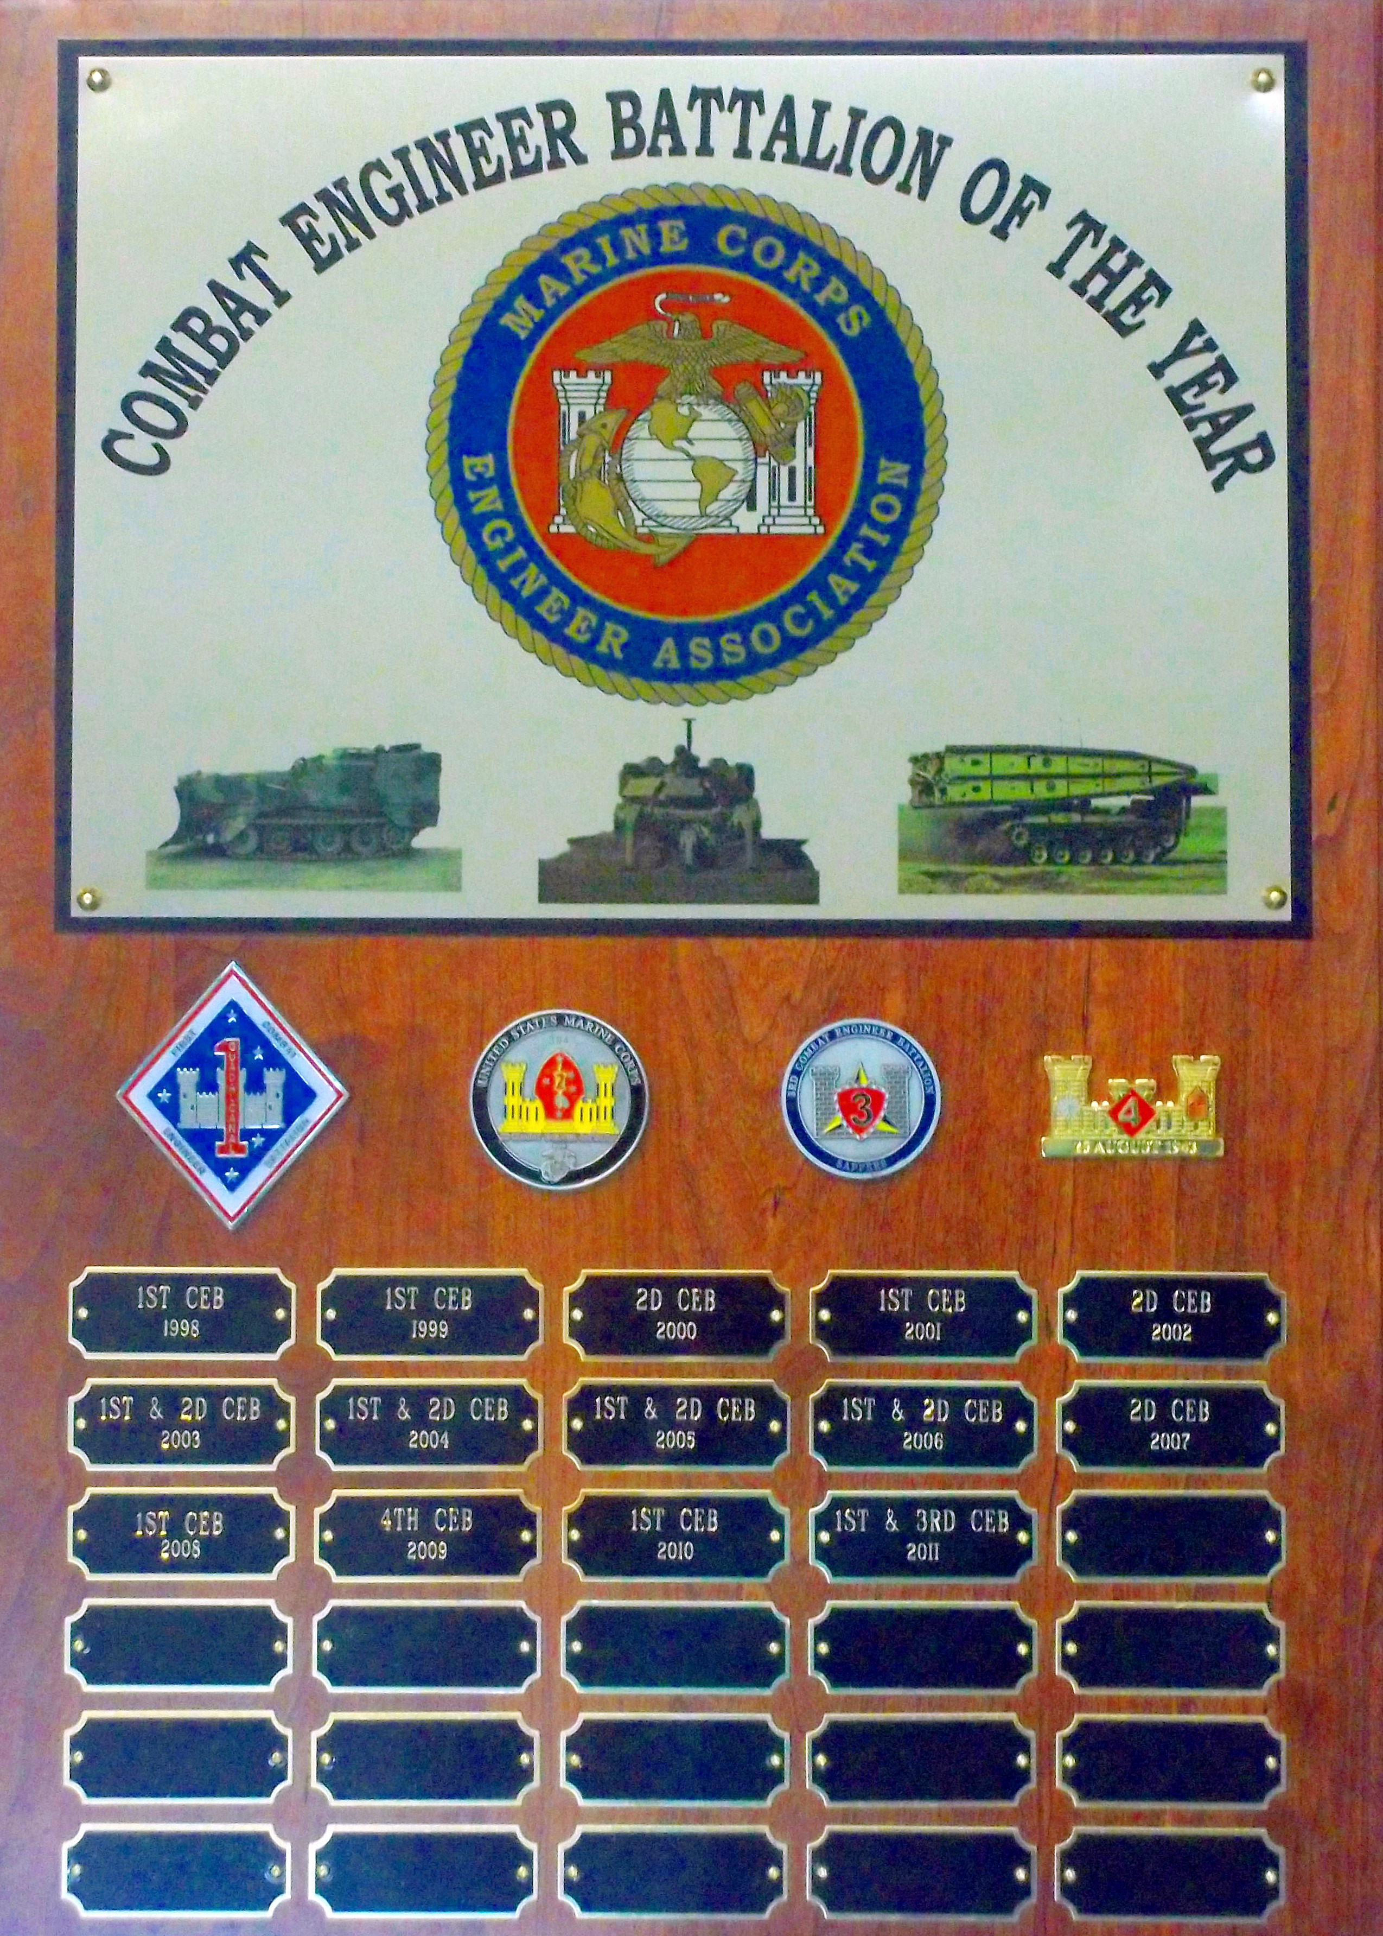
THE MARINE CORPS ENGINEER ASSOCIATION TAKES PLEASURE IN PRESENTING THE

ENGINEER SUPPORT BATTALION OF THE YEAR AWARD TO

8TH ENGINEER SUPPORT BATTALION

FOR SERVICE SET FORTH IN THE FOLLOWING:

For meritorious service and exemplary performance in providing general engineering support in support of 2d Marine Logistics Group, II Marine Expeditionary Force from 1 April 2010 to 31 March 2011. Providing tactically agile and operationally responsive general engineer support to Marine Forces Command, U.S. Southern Command, and Marine Central Command, the Battalion supported humanitarian and disaster relief operations as well as providing seven separate deploying engineer formations for Marine Expeditionary Units and Combat Logistics Battalions deploying to Afghanistan. Turning over a nearly complete command and staff, the Battalion aggressively readied itself in four short months for a seven month combat deployment to Afghanistan in support of Operation ENDURING FREEDOM 10.2. Throughout this deployment, the Battalion exceeded its combat missions and was the linchpin in the successful opening of the Upper Sangin River Valley corridor, enabling both ground combat elements and logistic combat elements the freedom of maneuver and mobility necessary to interdict insurgents and support coalition forces. the Battalion executed 102 combat logistics patrols moving over 74 million pounds of war materiel while simultaneously conducting over 650 motorized security patrols. Supporting the Carolina MAGTF, the Battalion’s Force Generation Element trained and deployed two additional engineer formations and prepared for another engineer line company to deploy later in the year to Afghanistan. In addition to these preparations, the force generation element continued to provide sustained and relevant general engineering and transportation support to the Marines and Sailors of II Marine Expeditionary Force as well as coalition partners conducting amphibious assault exercises aboard Camp Lejeune. The positive global impact of the Marines and Sailors of 8th Engineer Support Battalion throughout this period reflected great credit upon themselves, the Marine Corps and the United States Naval Service.
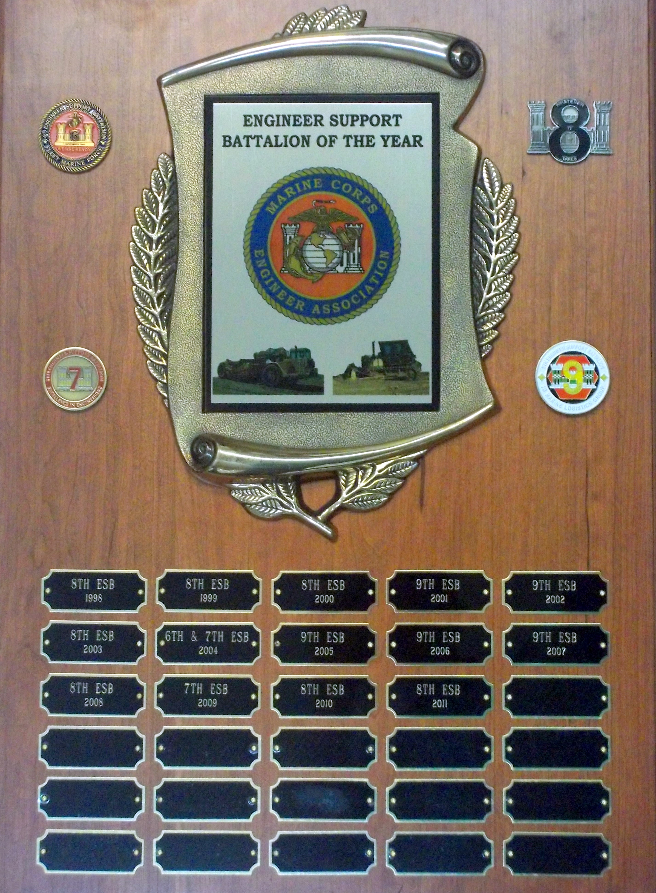
THE MARINE CORPS ENGINEER ASSOCIATION TAKES PLEASURE IN PRESENTING THE

MARINE WING SUPPORT SQUADRON, ENGINEER COMPANY
OF THE YEAR AWARD TO

MARINE WING SUPPORT SQUADRON 373

FOR SERVICE SET FORTH IN THE FOLLOWING:

SUPERIOR ACHIEVEMENT IN ENGINEERING OPERATIONS IN SUPPORT OF MARINE WING SUPPORT SQUADRON 373, MARINE WING SUPPORT GROUP 37, 3D MARINE AIRCRAFT WING FROM 1 APRIL 2010 TO 26 SEPTEMBER 2010 AND IN SUPPORT OF 3D MARINE AIRCRAFT WING (FORWARD) FROM 27 SEPTEMBER 2010 TO 31 MARCH 2011. DURING THIS PERIOD THE ENGINEER COMPANY WAS RESPONSIBLE FOR ACCOMPLISHING TRAINING AND DEPLOYMENT IN SUPPORT OF OPERATION ENDURING FREEDOM 10.2. ENGINEER COMPANY WAS DIRECTLY RESPONSIBLE FOR THE PROFESSIONAL EXECUTION OF BOTH WEAPONS AND TACTICS INSTRUCTOR COURSE 2-10 AND ENHANCED MOJAVE VIPER 5-10 DURING WHICH THEY EXHIBITED THE INVENTIVE PROBLEM SOLVING AND IMPECCABLE SAFETY RECORD WHICH ARE HALLMARKS OF THE ENGINEER COMMUNITY. WHILE DEPLOYED, THE COMPANY’S SUPERVISION AND SYNCHRONIZATION OF THE CONSTRUCTION AND MOVE OF THE SUPPORTED FLYING SQUADRON’S CANTONMENT AREAS ABOARD JOINT OPERATING BASE BASTION INCLUDED THE FABRICATION OF TWO 128 FOOT BY 32 FOOT WOOD FRAMED STRUCTURES, TEN CLAMSHELL STYLE LARGE AREA MAINTENANCE AIRCRAFT SHELTERS PROVIDING 217,734 SQ FT OF COVERED MAINTENANCE SPACE, A 500 FOOT BY 300 FOOT ROTARY WING ARRIVAL AND DEPARTURE AIR FIELD CONTROL GROUP PAD, AND ALL OF THE ASSOCIATED UTILITIES LIFE SUPPORT USED TO ENSURE THE UNINTERRUPTED CONTINUATION OF FLIGHT LINE OPERATIONS. SUBSEQUENT EFFORTS AT INCREASING EFFICIENCY AND REDUCING COSTS ASSOCIATED WITH ENGINEERING AND CONTRACTOR SUPPORTED OPERATIONS POSITIVELY IMPACTED THE SORTIE GENERATION OF 3D MARINE AIRCRAFT WING (FORWARD) AND AVAILABLE FORCE PROJECTION IN SUPPORT OF REGIONAL COMMAND (SOUTHWEST). THE POSITIVE GLOBAL IMPACT OF MARINE WING SUPPORT SQUADRON 373’S ENGINEER COMPANY THROUGHOUT THIS PERIOD REFLECTED GREAT CREDIT UPON THEMSELVES, THE MARINE CORPS AND THE UNITED STATES NAVAL SERVICE.
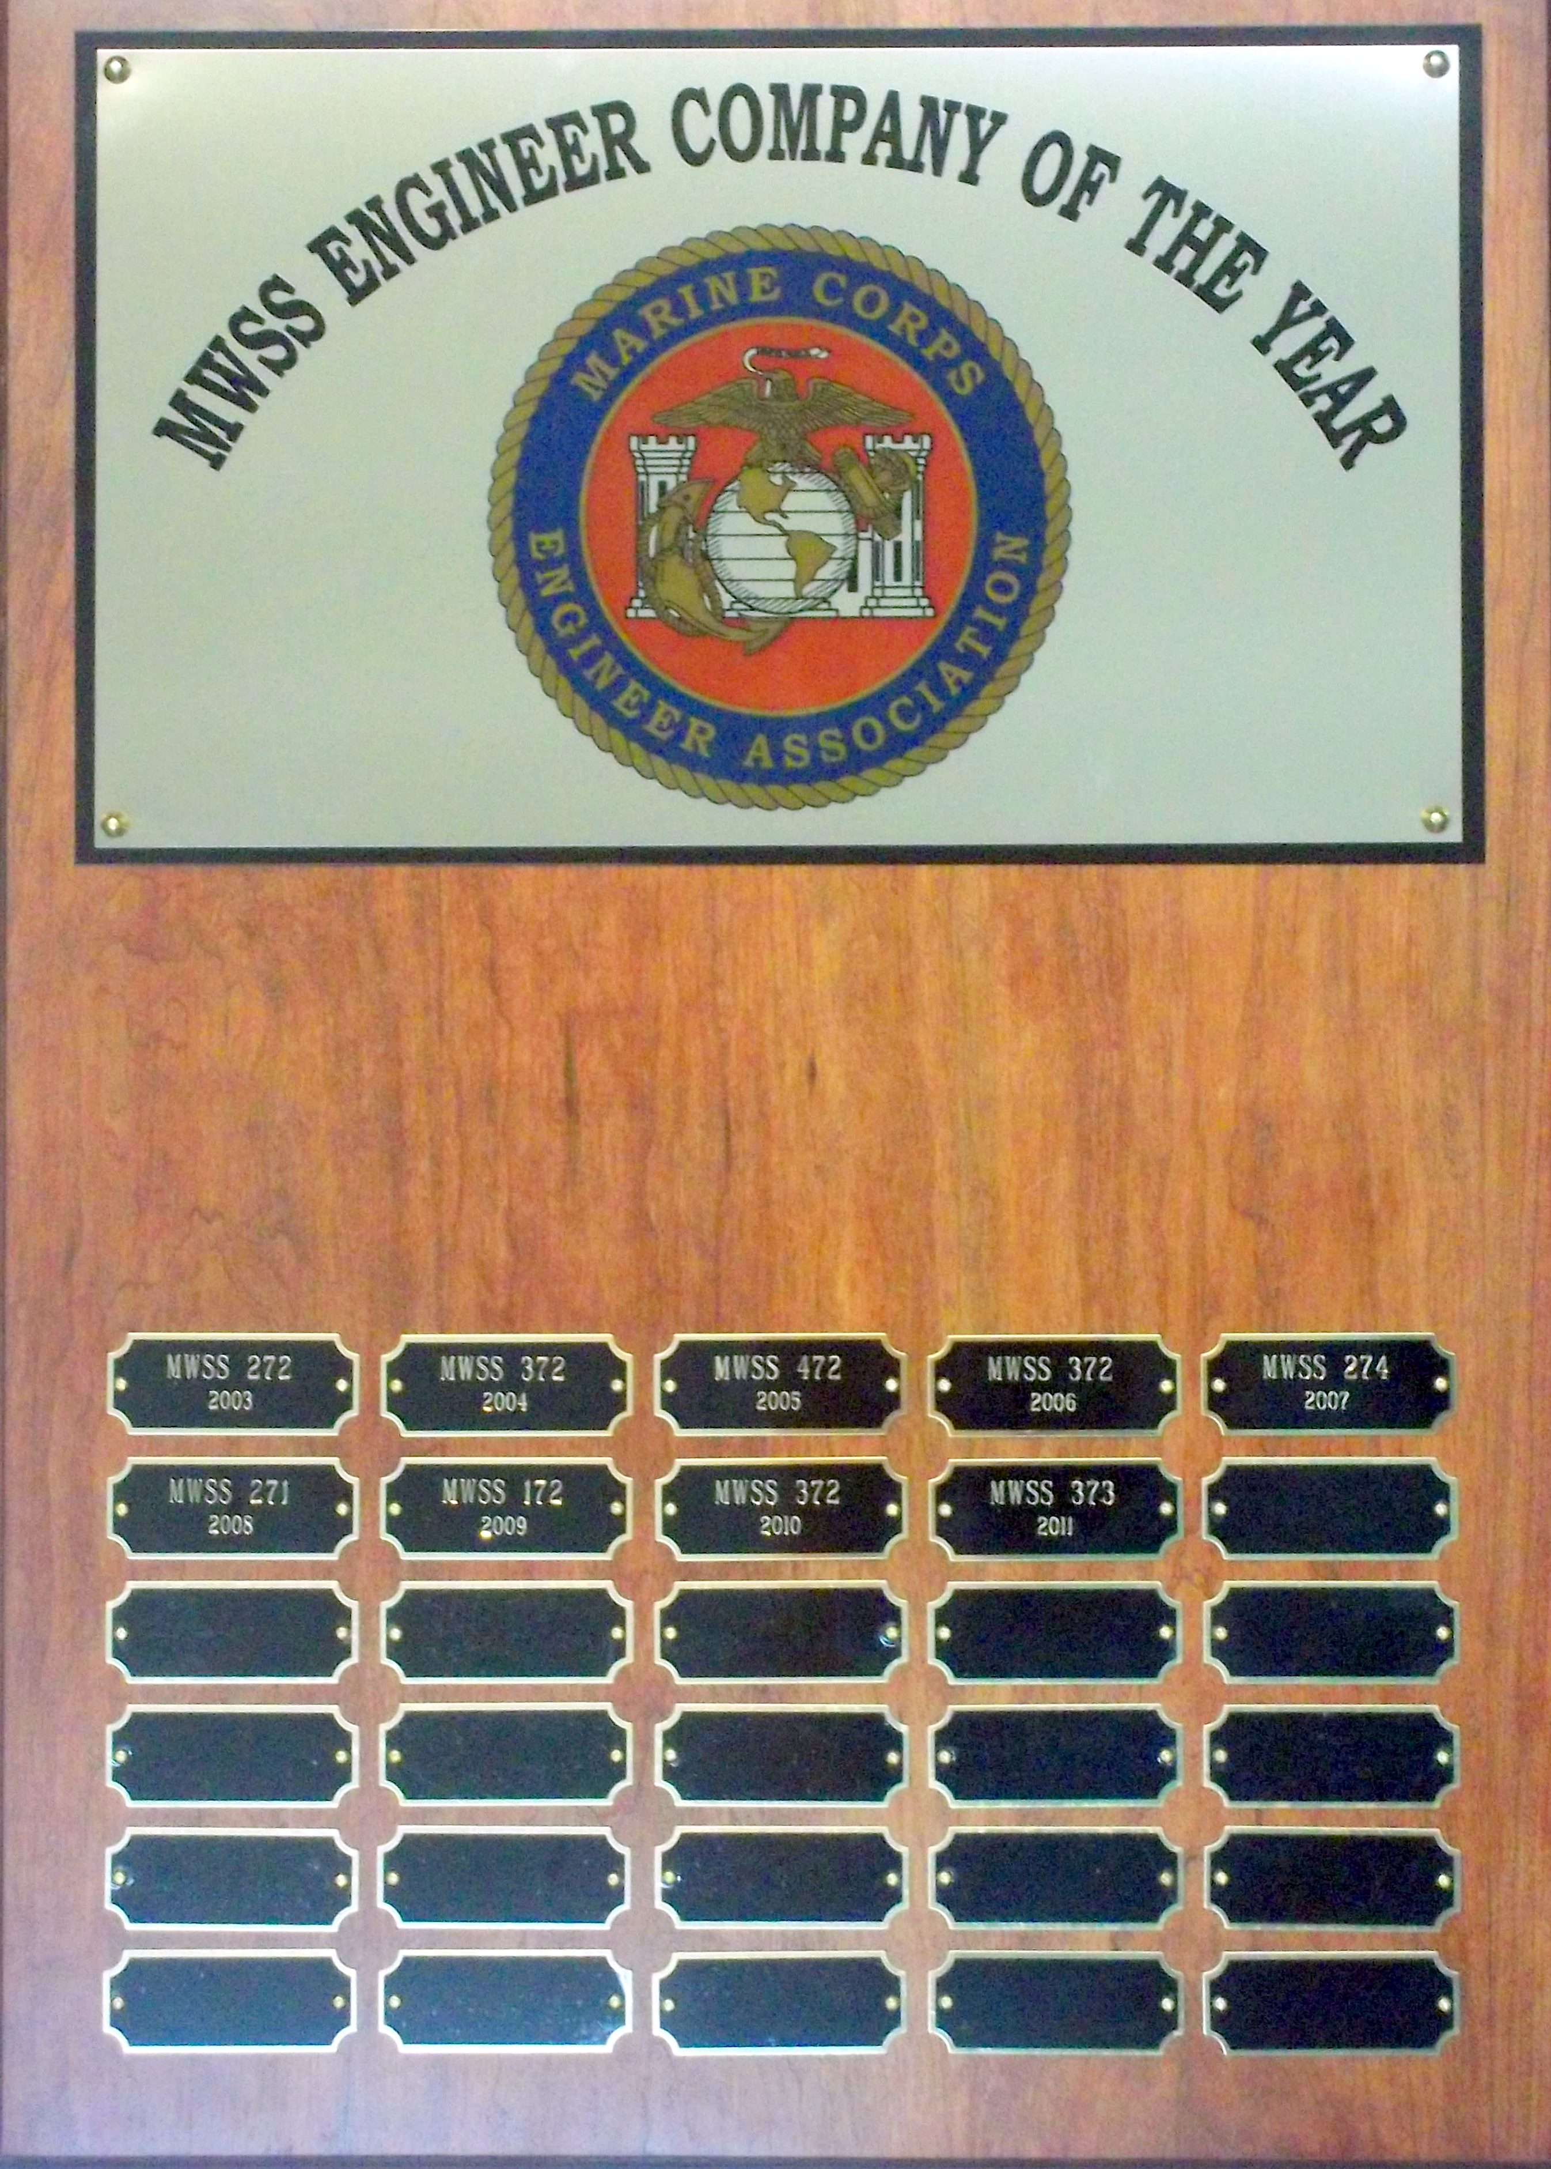
THE MARINE CORPS ENGINEER ASSOCIATION TAKES PLEASURE IN PRESENTING THE

OUTSTANDING NAVAL CONSTRUCTION FORCE UNIT OF THE YEAR AWARD TO

NAVAL MOBILE CONSTRUCTION BATTALION FIVE

FOR SERVICE SET FORTH IN THE FOLLOWING:

For exemplary performance and meritorious service for providing superlative contingency engineer support to I Marine Expeditionary Force (I MEF) from 1 April 2010 to 16 November 2010. This period began with the battalion deploying on short notice to support I MEF in the Helmand Province. NMCB FIVE’s superior performance in vertical and horizontal construction, counter-mobility, and force protection missions included construction of berms, HESCO barriers, airfield expansions, ammunition storage units, command and control facilities, road improvements, river crossings and bridging operations throughout Afghanistan, over 100 projects in all. At Camp Leatherneck alone, 50 Southwest Asia Huts averaging 120 feet by 32 feet were constructed for critical command and control, chapel, entry control points, supply operations, and other uses to support combat operations. Additionally, on 16 May, a fire in I MEF’s Supply Management Unit (SMU) lot destroyed over $180 million in supplies and all SMU logistics offices. NMCB FIVE’s initiative and aggressive firefighting efforts kept fire from spreading to the adjacent fuel farm preventing additional property damage and potentially, loss of life. By their noteworthy accomplishment, impeccable professionalism and complete dedication to duty, the members of U.S. Naval Mobile Construction Battalion FIVE overcame tremendous danger and adversity to provide essential construction support to Marine units. Their hallmark achievements reflected great credit upon themselves and upheld the highest traditions of the Marine Corps and the United States Naval Service.

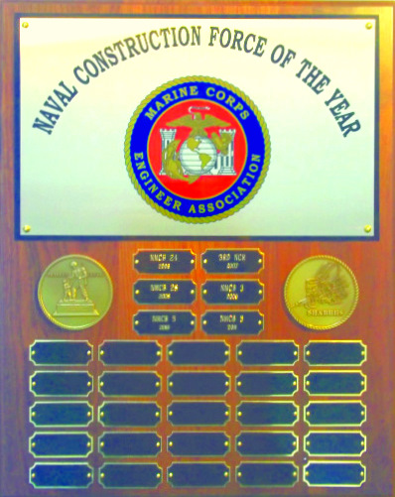
OUR MARINE CORPS ENGINEER ASSOCIATION EXPRESSes OUR genuine APPRECIATION TO THE FOLLOWING CORPORATE MEMBERS, THEIR REPRESENTATIVES and our sponsors FOR THEIR PARTICIPATION AND SUPPORT OF OUR ENGINEER BROTHERHOOD.

CATERPILLAR INC. DEFENSE & FEDERAL PRODUCTS
ACCOUNT MANAGER: john frame
SPONSOR OF ENGR SPT BN TROPHY

concurrent technologies corporation
representative: rod padgett, senior director
sponsor of utilities individual award category

MARINE CORPS BULK FUEL ASSOCIATION
PRESIDENT: CWO 4 NATE WILSON, USMC (RET)
SPONSOR OF BULK FUEL INDIVIDUAL AWARD CATEGORY

force protection industries
representative: tommy pruitt, senior communications director
sponsor of COMBAT ENGR BN TROPHY AND combat engr and eod individual award categories

hntb federal
representative: dave mCmiller
sponsor of MWSS ENGR CO TROPHY

KALMAR RT CENTER
REPRESENTATIVE: dave peacock, EXEC VP, military products and supply
sponsor of engineer equipment individual award category

society of american military engineers
representative: dr. bob wolff, executive director
sponsor of awardee banquet costs

TEREX CORPORATION
REPRESENTATIVE: MATTHEW DOBBS, Director of SALES, CRANES Division
SPONSOR OF NAVAL CONSTRUCTION FORCE UNIT AWARD

ingenieur executive search
representative: ms. samantha sferas

PEARSON ENGINEERING
REPRESENTATIVE: john crompton

science applications internationAL corporation
representative: shane evans, div mgr, expeditionary warfare & logistics

sea box incorporated
representative: jim brennan, jr, president

TABLE SPONSORS: CATERPILLAR; FORCE PROTECTION INDUSTRIES; HNTB FEDERAL;
KALMAR RT; TEREX; MONTY NEREIM AND ROB DeBUSSEY

MCEA would like to extend our sincere gratitude to checkerboard industries for the generous donation of a portion of the cost of the golf shirts being presented to the award RECIPIENTs.

The Rusty Marine
The rusty Marine, born gallant and brave,
To his country, his allegiance was raised.
He served in war to honor and protect,
While in battle, he did not defect.

Through foxholes, trenches, gunfire and hell,
His honor and pride never fell.
For in his heart, his faith was strong,
And yet for home, he did long.

Our great land protects the free,
For this he fought; for you and me.

Now he sits, tired, and worn,
For his youth, he does mourn.
Because it ran so quickly by,
He often thinks, “How time did fly,”

Then he dons his old dress blues,
And in his spirit, a change of hues.
He straightens up and stands with pride,
His great honor, he cannot hide.
Gently then, he begins to weep,
The memories come, pile upon heap.
A single tear falls from his eye,
As he whispers, “Semper Fi”.
Submitted by 1stSgt Bob Canright, USMC (Ret)

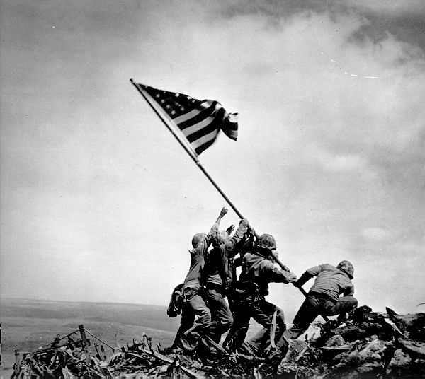
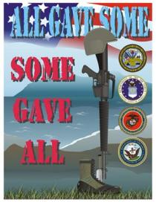

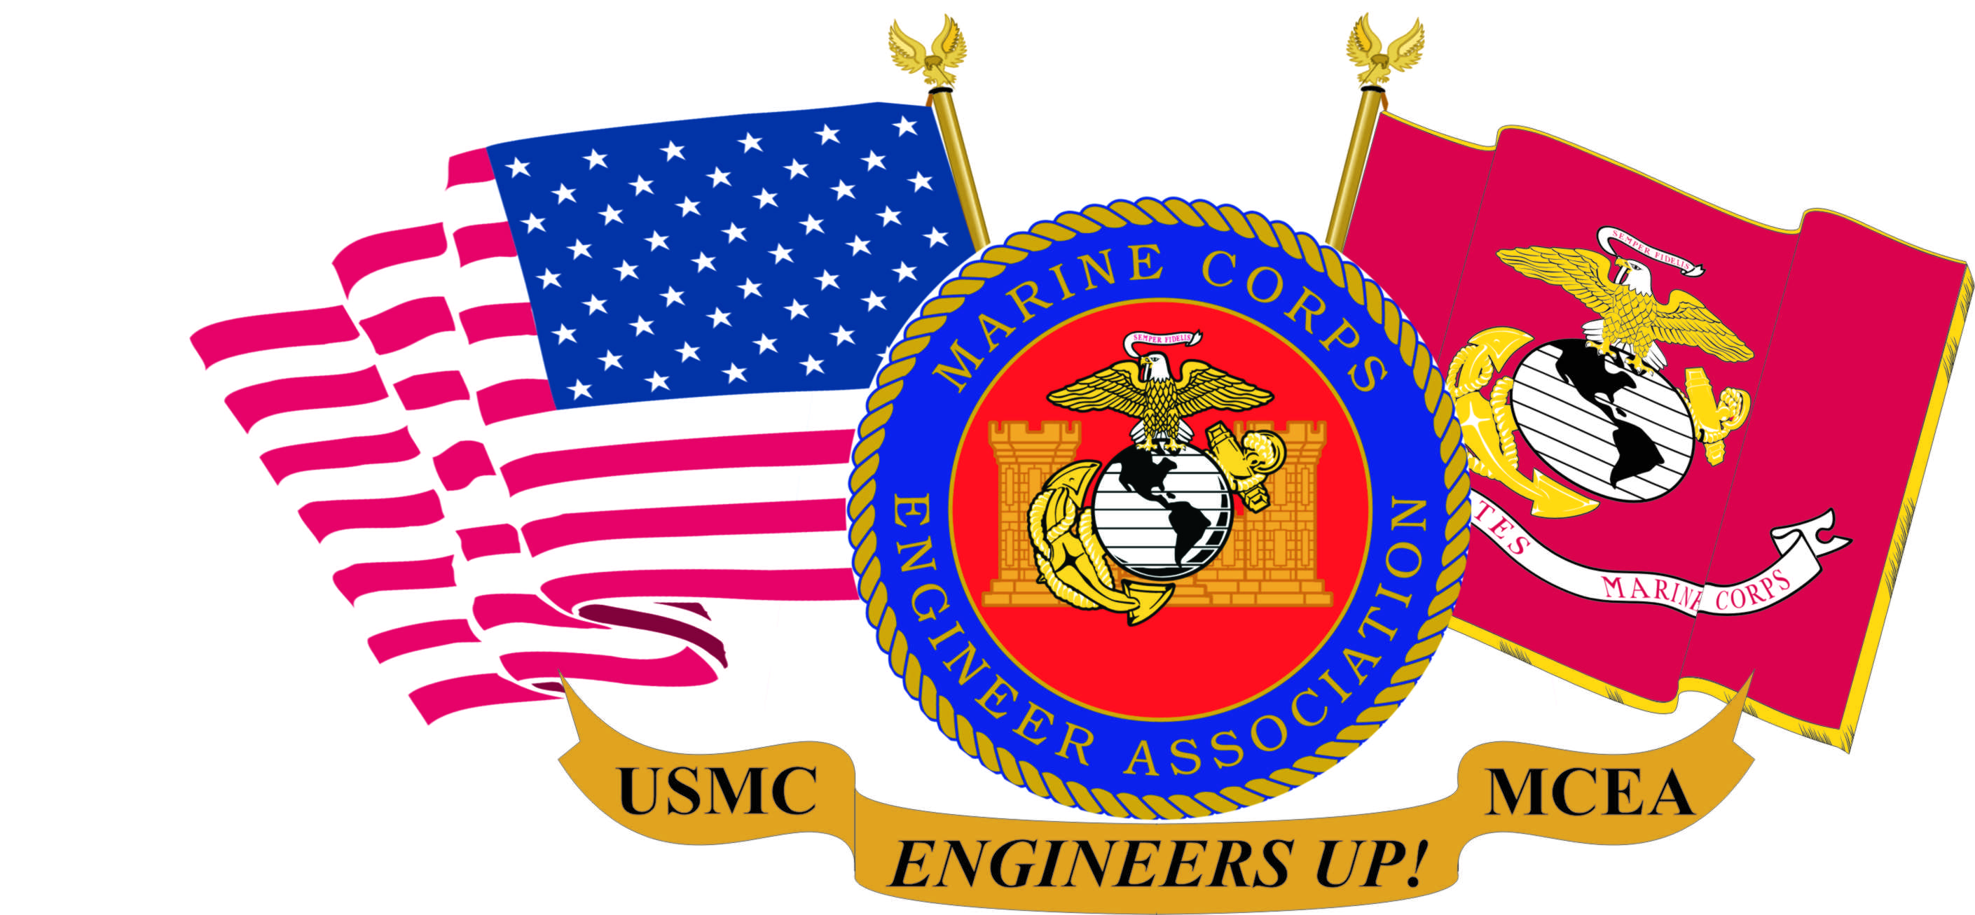

WWW: MARCORENGASN.ORG

