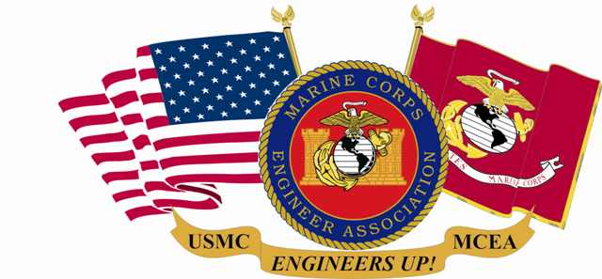
MARINE CORPS ENGINEER ASSOCIATION

What is it? The MCEA is a HQMC sanctioned, tax-exempt, nonprofit organization (IRS 501 (c) (19)), incorporated in NC, in 1991.

MCEA Purpose/Bylaw highlights:
- Promote Marine Corps engineering in combat engineer, engineer equipment, utilities, landing support (shore party), bulk fuel,
topographic and construction engineering, drafting, and Explosive Ordnance Disposal (EOD)
- Renew and perpetuate fellowship of retired, former and current US Marines who served with Marine Corps Engineer units and sister
service members who served in support of Marine-Air-Ground Task Force (MAGTF) Units
- Preserve the memory of those who served
- Promote an accurate historical record of the contributions of Marine Corps engineers
- Foster solidarity of Marine Corps engineers
- Keep members current with the Marine Corps engineer community
- Annually recognize superior achievement of active duty and reserve establishment Marine Corps EOD and engineer individuals & organizations, as well as Naval Construction Force Units

MCEA Eligibility. All former and current Armed Forces personnel who served with Marine Corps Air Ground Task Force (MAGTF) Units or in support of Marine Corps Engineer Units or US Marine Corps Base and Station billets.

Membership Benefits:
- Very affordable dues for yearly, multi-year & lifetime membership! 100% of dues and all contributions are tax deductible.
- Contributions to MCEA, Unit brick program and school sponsorship qualify for the Fellows Program.
- Access to members’ roster and capability to locate and reconnect with Marines and Sailors from former units
- Annual reunion with opportunity to interact with veterans as well as active/reserve duty personnel, corporate members and
“Best of the Best” award recipients and their families
- Subscription to MCEA newsletter
- Notification of employment opportunities especially in the DOD and civilian engineering community
- Capability to interact daily with other members via website and email and receive updates from MCEA
- Unlimited access to website and special “members only” section
- Access to history, lineage and other information about USMC engineer units
- Availability of unique MCEA Ship’s Store items; - Discounts on Military Historical Tours, Inc

MCEA Engineer Monument . Dedicated 14 May, 2014, as an enduring tribute to all Marine Corps Engineers, past, present and future in the Semper Fidelis Park at the National Museum of the Marine Corps. Personalized and unit bricks available for purchase to be located adjacent to our Engineer Monument.

Sponsorship of engineer related formal school courses. Opportunity to sponsor any of the 1000 graduates in the 20 annual courses.

Bottom Line: MCEA provides a unique opportunity to connect or reconnect and maintain communication with Marine Corps engineers, the Marine Corps family, recognize outstanding performance of individual Marines and engineer and Seabee organizations and to leave a memorable legacy for our Marine Corps engineer brotherhood.

Reunions/Awards Banquets: Camp Lejeune, NC ’92, ’93,’99, ’07, ‘15; Camp Pendleton, CA ’94; ’08, ’14; Gatlinburg, TN ’95; Wilmington, NC ’96; Denver, CO ’97; Savannah, GA ’98; Quantico, VA ’00, 10; Branson, MO ’02, ‘12; Harrisburg, PA ’03; Portland, OR ’04; Myrtle Beach, SC ’05; Boston, MA ‘06; Las Vegas, NV ’09, ‘22; San Diego, CA ’11. Orlando, FL ’13; Pala, CA ’14, ’16; Fredericksburg, VA ’17,21; San Diego, CA ’18; San Antonio, TX ’19.

MCEA, PO Box 279 Beechgrove, TN 37018-0279

931-307-9094

GET ALL THE DETAILS AT: WWW.MARCORENGASN.ORG

